Albury Basketball Association 2021 Basketball Trials!
U12s & U14s First Trial- Sunday 18th October – Lauren Jackson Sports Centre
U12 Girls (2010/2011/2012) 12:00pm to 2:00pm U12 Boys (2010/2011/2012) 12:30pm to 2:30pm U14 Girls (2008/2009) 2:30pm to 4:30pm U14 Boys (2008/2009) 3:00pm to 5:00pm

U16s & U18s First Trial- Sunday 25th October – Lauren Jackson Sports Centre U16 Girls (2006/2007) 12:00pm to 2:00pm U16 Boys (2006/2007) 12:30pm to 2:30pm U18 Girls (2004/2005) 2:30pm to 4:30pm U18 Boys (2004/2005) 3:00pm to 5:00pm

ALL AGE GROUPS FINAL TRIAL - Sunday 1st November
Lauren Jackson Sports Centre
U12 Girls (2010/2011/2012) 8:00am to 10:00am U12 Boys (2010/2011/2012) 8:15am to 10:15am U14 Girls (2008/2009) 10:15am to 12:15pm U14 Boys (2008/2009) 10:30am to 12:30pm
U16 Girls (2006/2007) 12:30pm to 2:30pm U16 Boys (2006/2007) 12:45pm to 2:45pm
U18 Girls (2004/2005) 2:45pm to 4:45pm U18 Boys (2004/2005) 3:00pm to 5:00pm

Do you want to:

Play Basketball in the NSW Basketball Waratah League Country competition

Have the opportunity to be identified for elite BNSW programs

Learn from the best coaches, in a learning environment, that has a clearly stated development curriculum called “The Cougars Way”

Make great friendships with like-minded, motivated kids

IMPORTANT – Please do not wear Albury Cougars, Basketball NSW Country or Basketball NSW apparel to try-outs.
Domestic singlets and shorts are allowed or comfortable clothes for basketball training purposes.
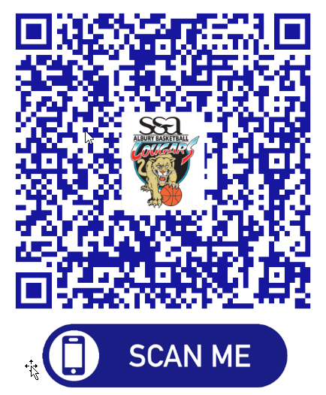
All players attending trials
- Please complete and sign the “online ABA Cougars intention to trial form” (due 15 OCT) Simply scan the QR Code provided or visit our ABA website http://albury.basketball.net.au

- Will be required to pay $20 cash on arrival to trial (covers court hire for the two days)

- Are asked to please arrive 15 minutes prior to the scheduled start, dressed in Basketball playing/training gear including mouth guard, and any personal strapping if required. (You should use this time to warm up and stretch)

Please bring a basketball, water bottle, and any medication (Asthma puffers, etc.) clearly marked with your name if needed.
For more info:
Email: admin@alburybasketball.com.au
Visit our website: http://albury.basketball.net.au

