25.06.2020
Following discussion with our member clubs and recent COVID-19 announcements by the Premier of Victoria Mr Daniel Andrews, which outlined the tightening of some social distancing measures and the threat of a secondary COVID-19 wave, Mid Gippsland Football Netball League (MGFNL) believe the most socially responsible decision is to abandon our 2020 Senior Football and Netball competitions.
We having been in constant dialog with our member clubs and agree the absolute and responsible actions moving forward should remain focused on the safety and welfare of all community members and club sustainability. We trust this decision will be viewed as a significant contribution to help end the threat of COVID-19 in Victoria despite the angst we know this decision will bring to many.
Throughout our decision-making process we have considered the unknown demands and implications around additional workloads on club volunteers, compliance and monitoring records for clubs and past uncertainty around crowd participation.
Whilst we acknowledge these are unprecedented times these issues exacerbate the frustrations everyone is experiencing within community sport. We appreciate the support of all volunteers during these difficult times and trust every player and volunteer will return in future years.
In conclusion whilst we cannot proceed with season 2020 we will be focusing on junior retention and junior development programmes providing opportunities for our junior football and netball competitions, and preparing for an exciting 2021 of competition.

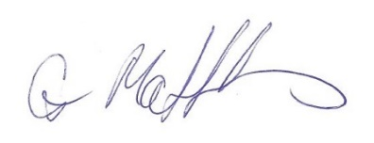
Gary Matthews
President MGFNL

