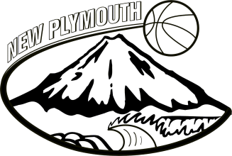
Information for Basketball Tournament – Easter Weekend.

U15 Girls Easter Tournament
24th – 28th March in Tauranga

Accommodation: Cottage Park Thermal Motel Tauranga
Phone: 0800 268 8243
Address: 19 Hairini St Welcome Bay, Tauranga

Travel: Leaving From: TSB Stadium Thursday 24 March in the afternoon time TBC. All players to travel together. Please provide packed lunch.
Returning: Monday 29 March Time TBC

Fees: The Fees for Easter Tournament have been set at $300.00, leaving a balance of $200.00 payable

Please make direct payment to NPBA Association Account
15-3942-0005183-00. Payment due by 14th March please.

Equipment:

All personal items must be named or identified in some way. Management take no responsibility for items that players choose to take. One suitcase and one backpack to transport gear to and from the game (provided by NPBA) only please. Please pack light they will most be playing basketball and we will do washing so only a couple of changes of clothes needed.

Players will be provided with playing uniforms at tournament. Tracksuits (maybe) and NPBA bags will be issued at the last practice and are to be used travelling to tournament. All uniforms, tracksuits, and bags will be collected at the end of the tournament.

What to take:
- Playing shoes and one spare pair in case of emergencies
- Shoes to wear to and from the stadium e.g. slip on shoes
- Warm up top
- Plenty of sports socks
- Sports Towel
- Toiletries (toothbrush & paste, deodorant, shampoo, soap, facecloth, other personal items)
- Drink bottle
- Strapping tape (notify team manager of any injuries)
- Togs and Towel
- Sunscreen and hat
- Personal clothing and shoes for off the court time
- Spending money
- Medications (notify team manager)
- Washing bag or plastic bags to store used clothing

