APPENDIX: F – GROUND MARSHALL INCIDENT FORM

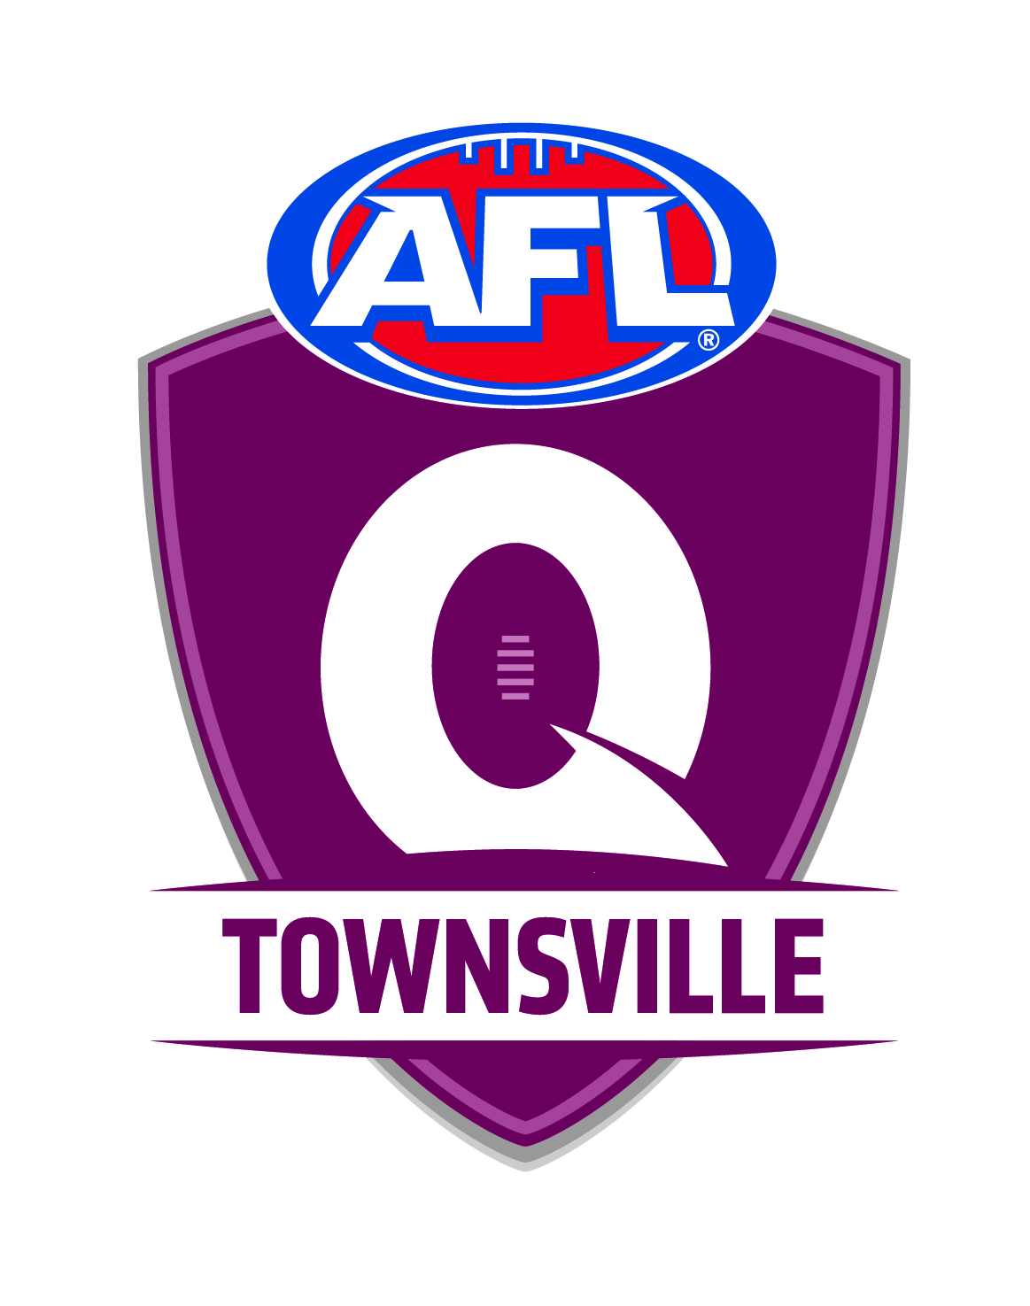 AFLT - GROUND MARSHALL INCIDENT FORM

This form is to be completed, kept by the club and a copy sent to AFL Townsville.

Ground Marshall Details

Name Club ________________________

Home Phone No. ________________________ Mobile Phone No. _________________________

Incident Details

Date / Time Location Venue _________________________________________________________________
___________________ ____________________________________ ____________________________
Age Group & Division Match Vs.

Type of Incident

- Breech of Code of Conduct
- Safety / Facility Breech
- Malicious Damage
- Property/Equipment Damage
- Theft
- Other

Give a brief overview of incident

_______________________________________________________________________________________________________________________________________________________________________________________________________________________________________________________________________________________________________________________________________________________________________________________________________________________________________________________________________

Give brief overview of action taken by Club

____________________________________________________________________________________________________________________________________________________________________________________________________________________________________________________________________________________________________________________________________________________________________________

Is further action required? (Please circle) Yes No

________________________________________ _____________________
Ground Marshall Signature Date

PARENTS CODE OF CONDUCT
All parents are requested to carefully read the Codes of Behaviour and parent education undertaking.
1. Remember that children play sport for their enjoyment not yours;
2. Encourage children to participate, do not force them;
3. Focus on the child’s effort and performance rather than winning or losing;
4. Encourage children to always participate according to the rules;
5. Never ridicule or yell at a child for making a mistake or losing a game;
6. Remember that children learn by example. Applaud good play at all times;
7. Support all efforts to remove verbal and physical abuse for sporting activities;
8. Show appreciation of volunteer coaches, officials and administrators. Without them your child could not participate;
9. Respect officials decisions and teach children to do likewise;
10. The consumption of alcohol and smoking is inappropriate at all junior games.

COACHES CODE OF CONDUCT
1. I will respect the rights, dignity and worth of all individuals within the context of my involvement in the AFL game, including
refraining from any discriminatory practices on the basis of race, ethnic background, or special ability/disability;
2. I will abide by and teach the AFL Laws of the Game and the Rules of my Club and League;
3. I will be reasonable in the demands I make on the time commitments of the players in my care, having due consideration for
their health and well‐being;
4. I will refrain from any form of personal abuse or unnecessary physical contact with the players in my care;
5. I will have due consideration for varying maturity and ability levels of my players when designing practices schedules, practice
activities and involvement in competition;
6. Where I am responsible for players in the 5‐12 year old age group, I will ensure that all players gain equal playing time. I will
avoid overplaying talented players, aiming to maximize participation and enjoyment for all players regardless of ability;
7. I will stress and monitor safety always;
8. In recognizing the significance of injury and sickness, I will seek and follow the physician’s advice concerning the return of
injured or ill players to training;
9. I will endeavour to keep informed with regard to sound principles of coaching and skill development, and to factors relating to
the welfare of my players;
10. I will at all times display and teach appropriate sporting behavior, ensuring that players understand and practice fair play;
11. I will display and foster respect for umpires, opponents, coaches, administrators, other officials, parents and spectators;
12. I will ensure that players are involved in a positive environment where skill learning and development as priorities are not
overshadowed by a desire to win;
13. I reject the use of performance enhancing substances in sport and will abide by the guidelines set forth in the AFL Drug Policy.

ADMINISTRATION/OFFICIALS CODE OF CONDUCT
1. Ensure that equal opportunity for participation in sports are made available to all children regardless of ability, size, shape, sex,
age, disability or ethnic origin;
2. Ensure that rules, equipment, length of games and training schedules take into consideration the age, ability and maturity level
of participating children;
3. Ensure that adequate supervision is provided by qualified and competent coaches and officials capable of developing
appropriate sports behavior and skill technique;
4. Ensure that parents, coaches, sponsors, physicians and participants understand their responsibility regarding fair play;
5. Modify rules and regulations to match the skill level of children and their needs;
6. Condemn unsporting behavior and promote respect for all opponents;
7. Ensure that your behavior is consistent with the principles of good behavior.

AFL Townsville MUST receive this form by 10.00am on Monday morning after completion of game:
FAX: (07) 4723 4300 or Email: aflt.secretary@gmail.com

