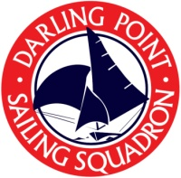
BOAT REGISTRATION - 2017-18

Class of boat
Name of boat
Sail number or insignia
Boat owner
Boat insurance
Boats sailed at Darling Point Sailing Squadron must have at least $10million in public liability insurance per incident. Please indicate below insurance details of this boat.
Insurance company
Policy number
Policy expiry date
Liability cover |  | $
Skipper and crew must hold a current Australian Sailing number to sail at DPSS
Skipper |  |  |  |  | Phone contact
Australian Sailing number:
Skipper Emergency contact name |  |  |  |  | Emergency Phone contact
Crew 1 |  |  |  |  | Phone contact
Australian Sailing number:
Crew 2 Emergency contact |  |  |  |  | Emergency Phone contact
Crew 2 |  |  |  |  | Phone contact
Australian Sailing number:
Crew 3 Emergency contact |  |  |  |  | Emergency Phone contact
You may prefer to pay a Season entry: Sabots $90; all other classes $150 (OR Weekly sign-on fee: Sabots $5; other classes $10)
Please tick payment method
Cash |  |  |  | Cheques payable to: Darling Point Sailing Squadron Inc.  Bank transfer: Include your last name as reference.
Cheque
Bank transfer |  |  |  | Date of transfer:

