History of Baseball on Saipan, Guam and Micronesia

By Bob Coldeen - CNMI & GUAM

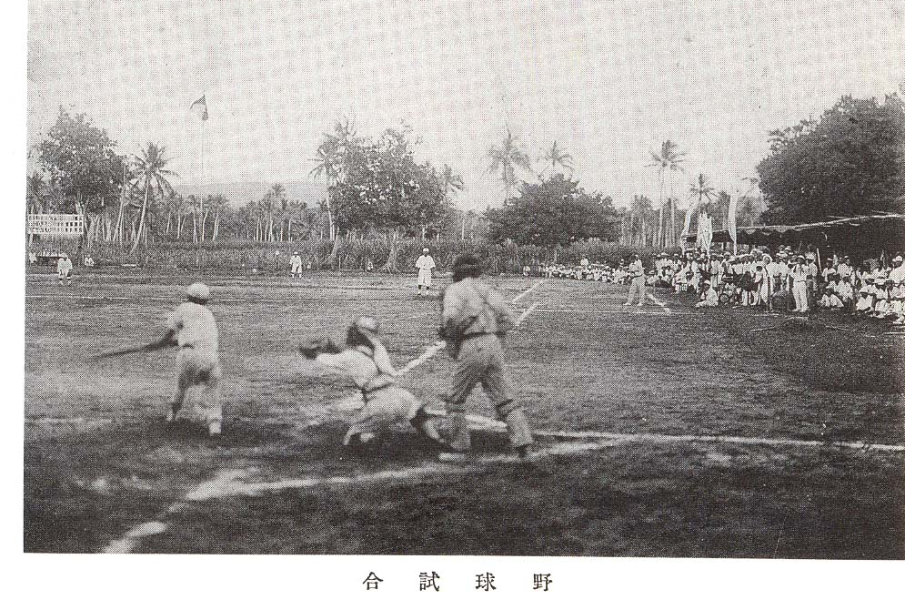
Chalan Kanoa, Saipan, c. 1930’s

Before the Japanese started playing baseball on Saipan, one hundred and twenty miles to the south, U.S. military played on Guam which was the first baseball played in Micronesia. Following the signing of Treaty of Paris in 1898, the United States sent Marines to Guam where they imported the sport. Baseball immediately captured the interest of the indigenous Chamorro population. Local players were talented enough for a team named the Natives to win the 1908 league championship.
In February of 1910 Japanese students on the ship Unyo Maru visited Saipan before sailing to Guam where they played a Sunday afternoon exhibition baseball game against the U.S. Marine Corps.
In 1911 there were only four teams in the league but by 1913 the Guam Mid-Winter League had expanded to eight teams, including the Natives I & II. The Natives II, also called the Carabaos, won the championship over the Marines 5-4 on Taijeron’s triple off the wall in the bottom of the 8th inning. The Guam News Letter selected the “Bamboo” league all-stars including four indigenous players: ace pitcher F. Calvo, slick fielding shortstop Guzman, and outfielders Munoz and Munoz. First names were apparently not relevant then as they were not noted in the Guam News Letter, the only newspaper on the island at that time. Calvo was noted for mastering the “wet ball” which was legal at that time.

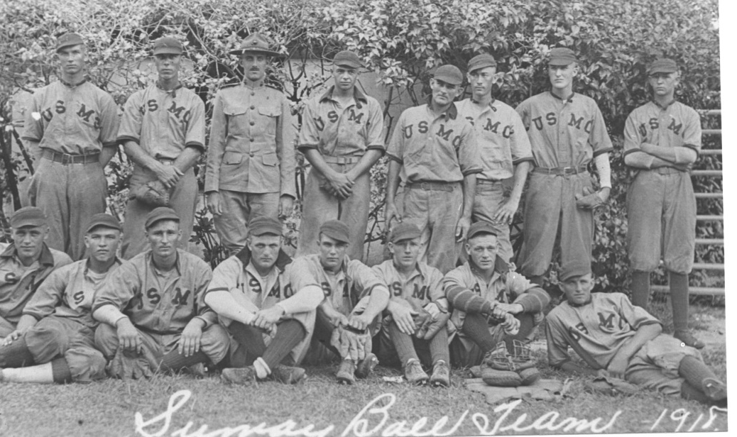
Guam League, Sumay Marines, 1918

The first Japanese residents on Saipan were a small military contingent in 1914 after a takeover from Germany. Five years later, the League of Nations mandated the Northern Marianas to Japan whose expatriate population swelled to forty-two thousand people by 1937 following an agricultural boom as Rota, Tinian and Saipan developed into a major food basket for Japan.
Although Germany had administered Saipan, their expatriate colony topped out at only eighteen people in 1906. Germans did not play baseball. Neither did the Spanish who administered the islands before the Germans, which meant that the people on Saipan never saw a baseball game until the Japanese presence, most likely in the in the 1920’s similar to Palau. Motoji Kono, who in 1922 went to Palau for the Japanese South Seas government and played baseball, is credited with being the founder of baseball there.
One of the first Chamorro pitchers from Saipan was Jose Salas Sablan (Consuelo) who did not learn how to pitch on Saipan or Guam, but in Palau where he worked as a train conductor. Born in 1907, he developed into an effective pitcher who in a 1927 game struck out a Japanese batter who told him that it was first time anyone from Palau had struck him out. The Japanese batter was so impressed, he saved that ball, and took it with him when he later returned to Japan.
Years after the war, in the 1970’s when both men had grown old, he wanted to meet the person who had struck him out in Palau in those years gone by. He found out that Sablan was on Saipan and traveled there as a tourist to present him with the ball. Consuelo was so overwhelmed by the gesture, he cried. Before he passed away, the father gave the ball to his son, Frank M. Sablan.

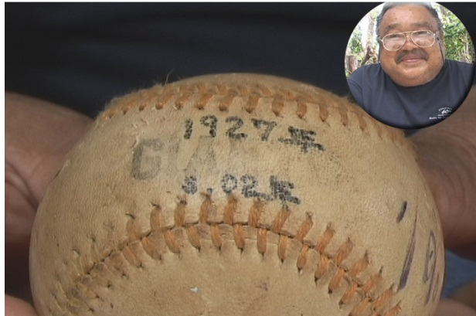
Jose Salas Sablan and 1927 baseball given to his son, Frank M. Sablan

As families came from Japan to the Northern Marianas, built homes, established businesses and opened schools. As baseball was Japan’s national pastime, the Japanese naturally brought baseballs, bats and gloves with them to play the sport they called yakyu. Chamorros and Carolinians, not having another word for baseball, called it the same.
On Saipan the Japanese organized military and civilian teams which did not include local Chamorros or Carolinians who had their own teams. One exception was Juan Blas Blanco who had learned how to pitch and throw a curveball while attending school in Japan. After returning to Saipan he was invited to play for the sugar company team NKK as a pitcher.

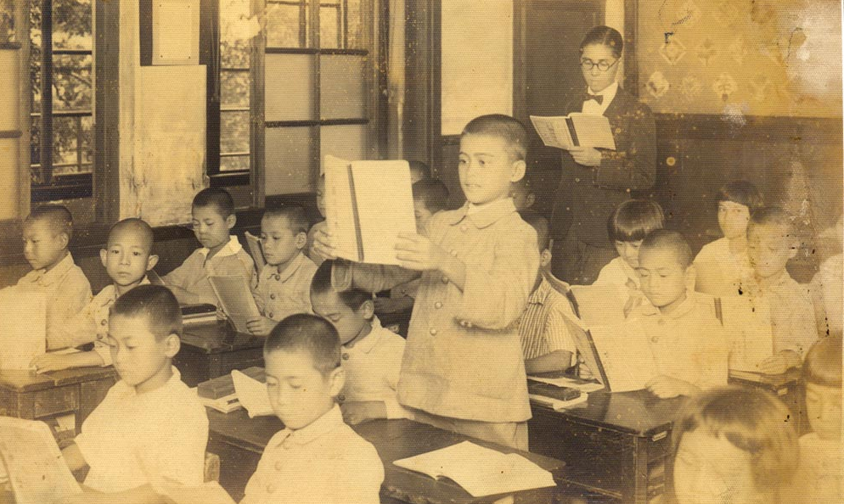
Juan Blas Blanco in a Tokyo school, 1934

During the Japanese times, games with cheering crowds were played on Sunday afternoons in Chalan Kanoa (one field was the Mount Carmel Cemetery is now and another where the elementary school was built in 1947). Games were also played in Puntan Muchot (American Memorial Park today). In 1939 a ten year old boy named Francisco Muna Palacios walked four miles from Chalan Kanoa to Puntan Muchot to watch the local teams play.
Pictures are rare from that era because Chamorro and Carolinians didn’t have cameras. And the Japanese government did not allow civilians to take pictures from 1938 to the American invasion due to the military build-up.
The war came and that was the end of fun and games.
Major Leaguer Harry O’Neill fought on Saipan before going to Iwo Jima where he died, one of only two major leaguers killed in World War II.
Bob Feller, Hall of Fame Major League pitcher, went to Saipan as a gunner aboard the USS Alabama. Feller claimed in his autobiography that he befriended future president Richard Nixon while fighting in the Marianas. Frank Deford repeated the claim in Sports Illustrated magazine. Baseball Almanac includes the following quote:

"I'm retired, so I got a call one day from Robin Roberts. He wanted me to introduce him and Bob Friend and the others to Richard Nixon, who was a lawyer in New York. When I consented to do, and I called Nixon, who I knew from Navy days in the Marianas.”
- Bob Feller

However, there is no record of Nixon ever serving in the Marianas, or engaging in combat or even being in the North Pacific.
Movie star, the “singing cowboy” Gene Autry toured the Pacific with the USO and visited Saipan where he played catcher in a fastpitch softball exhibition game. He later owned the baseball team California Angels. Jack Dempsey also visited Saipan with the USO.
In 1946 people settled into villages and baseball returned as the local’s favorite sport, and the only sport played other than races. U.S. servicemen helped promote the game by providing baseball equipment and competition.
The first “local” team after the war was the Police Team with Manny Villagomez (Kiyu) and Manny Sablan which fared well against three military teams
Major league baseball games on the radio were broadcast from California to the Far East and Saipan on the Armed Forces Network. Kiyu was up at two o’clock in the morning to listen to games that started at noon on the east coast of the United States. Blanco became a fan of the St. Louis Cardinals, and Stan Musial and Enos “Country” Slaughter.
So many boys and young men played that every village district had its own team. The game became popular enough, for example for the small village of Chalan Kanoa to field five teams. Rivalries soon developed.

Saipan Baseball League, 1954, Susupe

Students were taught the game of baseball at school by Richard King, a U.S. Marine. When his students defeated the Coast Guard team 11-3, he knew he had taught them well.
One of the young players, and a baseball fan, was Francisco Muna Palacios who had been introduced to baseball as a teenager attending school in Palau from 1943-1946 and having played in games there. Teams there were organized along ethnic lines, e.g. Ponapeans had a team, Trukese had a team, Chamorros had a team etc. and he had played at Asahi Field in Koror.
After returning to Saipan, Palacios worked at Naval Operation Base where he was fascinated by the Chicago Tribune sports section and the baseball box scores. He learned how to correctly score a baseball game from a Navy man.
Tan’Ko, as Palacios is also called, was not particularly adept at playing but loved the game and kept score for his first team, named Saipan Team, in 1953, the first organized league on Saipan following World War II.

Saipan Team won the first championship. Other teams from that era included Palau Association, Navy, Seabees, Braves, Youngsters, Coast Guard, Moon Stars, Tanapag, Mt. Carmel, Chalan Kanoa and San Roque.
Teams in those days had only nine or ten players and games were played every Sunday for six months, up to 20 games in a season. Antonio Salas recalls some of the players from those teams as follows:

Games were played at Law Field, Susupe, near where Marianas High School is now located, with doubleheaders: one game at nine o’clock in the morning, the second at one o’clock. Juan B. Camacho, a young outfielder, remembers taking pride in catching the ball in the ironwood trees. Mike Tenorio played catcher without a mask.

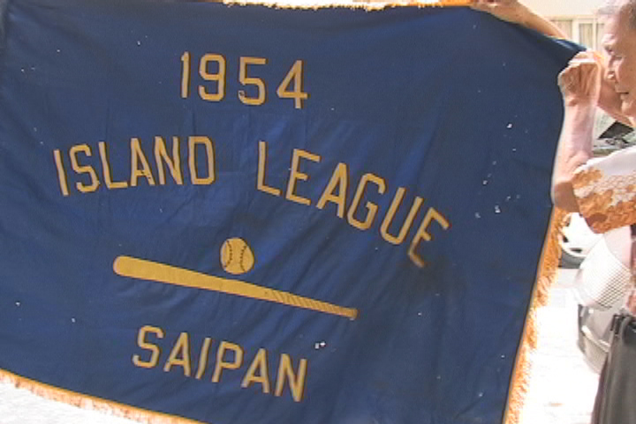
Championship Flag held by Frank Palacios 52 years after his team won it

Baseball was also played at Navy Field in Garapan where the Mariana Islands Housing Authority is housed. Another field was in Koblerville.
Not many local people had vehicles in those days and getting to games was arduous for many players. Sometimes a team would load up in a GI trailer hooked up to a Jeep to get to the field.
After watching games for more than fifty years, Palacios says that Jose Magofna a pitcher from Tanapag from Japanese times to the 1950’s was one of the greatest players in Saipan history and had been taken to Japan for training.
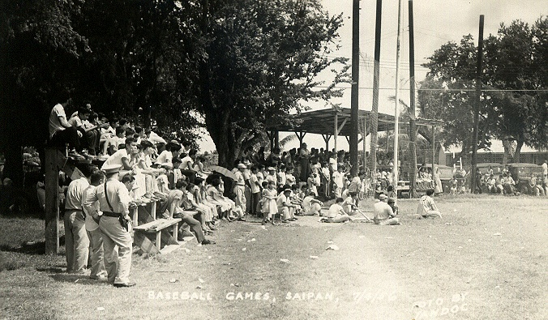
Wednesday July 4, 1956 baseball game in Chalan Kanoa, Saipan

The U.S. military flew two teams, the Bombers and Flyers, on their own plane from Guam to play two games on July 4, 1956. Exhibitions were also played on October 24 United Nations Day.
Although baseball flourished on nearby Guam, games between the two islands were not possible due to travel restrictions imposed in 1941 and not lifted until August 23, 1962 by United States President John F. Kennedy.
Special permission by the Naval administration was given to allow Saipan to play Guam in baseball for the first time in 1958. The Navy flew the Saipan team to Guam and the first game took place there at the Paseo de Susana, July 19, 1958. A second game a few days later against a selected military team was also scheduled. Interestingly, the July 24, 1958 edition of the Guam Daily News reported the historic games with a lengthy detailed description of the second contest, an 11-4 victory by the U.S. military over Saipan on July 22, but just one short sentence about the first game on July 19 when Saipan defeated Guam’s “local aggregation” 5-3.
Ricky (Ruth) T. Sablan was the winning pitcher in Saipan’s historic win in that first ever game against Guam.

1st Saipan team to play at Guam, July 19, 1958

Later that year, Guam sent a team to play on Saipan with considerably higher stakes: the winner would get all of the other team’s uniforms and equipment. Saipan won.
Saipan made two trips to Guam in the mid-60’s, splitting four games one year, and dropping all three games the following year.
Good sportsmanship was not always displayed in those days and fights were not uncommon. Saipan’s first recorded no-hitter, thrown by Babauta for the Giants against Tanapag July 4, 1967, was marred by a rock thrown at one of the players on the field. An umpire was chased away from the field. A player from the Palau team hiding with a spear gun and shot the umpire in the chin. A handgun was flashed in the Giants dugout. Nine innings of white-knuckle hardball somehow got played.
While baseball flourished in popularity within Saipan, there was no play against any other Micronesian islands until the 1969 Micronesian Olympics.
In the 1970’s fastpitch softball eclipsed baseball as the most popular sport, regularly drawing hundreds of people to night games at Mount Carmel field.
In 1972 the Saipan Baseball and Softball Association was formed with Dave Igitol as president. Players were basically the same for each sport.
Tan’Ko’s records prior to 1981 were destroyed in a fire at the Department of Community Affairs in Lower Base in November 1992. However, he maintained team and individual records for every year of Saipan Major League which started in 1982 and has annual seasons since then except 1984 due to field renovation for the Japanese professional team, Kintetsu Buffalos and 1987 following the destruction of Super Typhoon Kim. Dave Igitol served as President in 1982, succeeded by Tom Pangelinan, Bob Coldeen and Rose Igitol.

