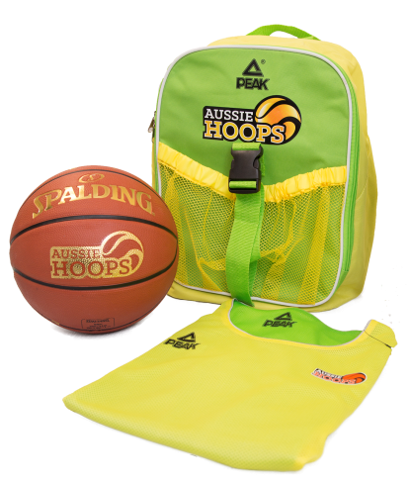

**Learn to Play Basketball for all kids 5-12 years**

**Commencing Sat 4th Aug 2018 at 9am – 10am**

**9 week Program - $110 for new participants; $85 for retuning participants**

**New players receive a backpack, ball and singlet.**

**Coaching by Patrick Williamson, CHBA Development Officer**

**To register for this program, please visit** [**www.aussiehoops.com.au**](http://www.aussiehoops.com.au)

**Or phone 66511452 for further information**

Come and join in at

Coffs Harbour Basketball