NEW FARM BOWLS CLUB

FUNCTIONS PACK

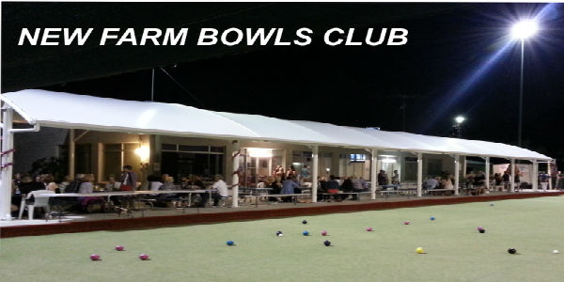

Opening times

Bar Kitchen

Monday: Closed Closed

Tuesday: 12noon till late Dinner from 6pm Bar Snacks 12-6pm

Wednesday: 12noon till late Dinner from 6pm Bar Snacks 12-6pm

Thursday: 12noon till late Dinner from 6pm Bar Snacks 12-6pm

Friday: 12noon till late Lunch from 12noon Dinner from 6pm Bar Snacks 12-6pm

Saturday: 10am till late Lunch from 12noon Bar Snacks 12-8pm

Sunday: 12noon till 6pm Bar Snacks 12-6pm

Location

New Farm Bowls Club is positioned directly opposite the beautiful New Farm Park at 969 Brunswick St.

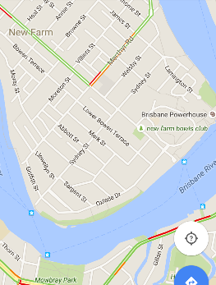

Public Transport is the best way to travel to the Club with Bus 196 at the front of the Club and City cat/Ferry terminal 100m at the end of Brunswick St. unfortunately the Club does not have a car park but all street parking in the area is unmetered.

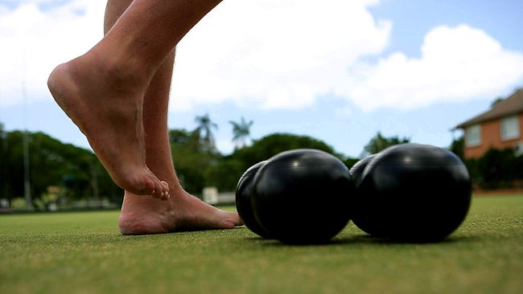

Barefoot Bowls

Monday N/A

Tuesday 1-3pm, 3-5pm, 5-7pm, 7-9pm.

Wednesday 1-3pm, 3-5pm, 5-7pm, 7-9pm.

Thursday 1-3pm, 3-5pm, 5-7pm, 7-9pm.

Friday 1-3pm, 3-5pm, 5-7pm, 7-9pm.

Saturday 11-1pm, 1-3pm, 3-5pm, 5-7pm, 7-9pm.

Sunday 1-3pm, 3-5pm, 5-7pm, 7-9pm.

The cost of barefoot bowls is $8pp before 5pm and $10pp after 5pm.

**In October, November and December barefoot bowls is charged at $80 per rink, up to 8 bowlers per rink.**

The 7-9pm session is not available during the months of May, June, July.

The price includes equipment, 2 hours of bowling plus instructions and tips from our barefoot bowls coordinators.

You are more than welcome to come as early and stay as late as you wish. The times stated are your **‘on the green’** times. Times can be flexible certain times of the year.

Kids of all ages are welcome. Cost $5 under 12.

The following rules are to be observed at all times:

* Bare feet only on the greens (socks are permitted)
* Children are to be supervised at all times
* No eating, drinking or smoking on the greens (drinks can be carried to the other end when necessary)
* No sitting on the edge of the greens
* Definitely no driving

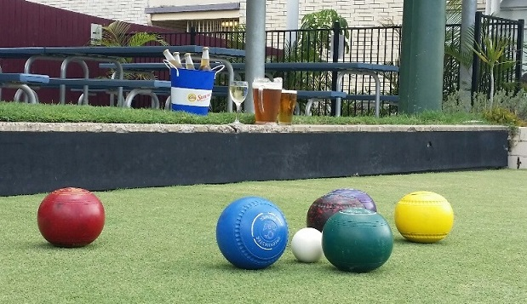

Function Areas

All our Function Areas are free of charge when catering is ordered.

**Function Room**

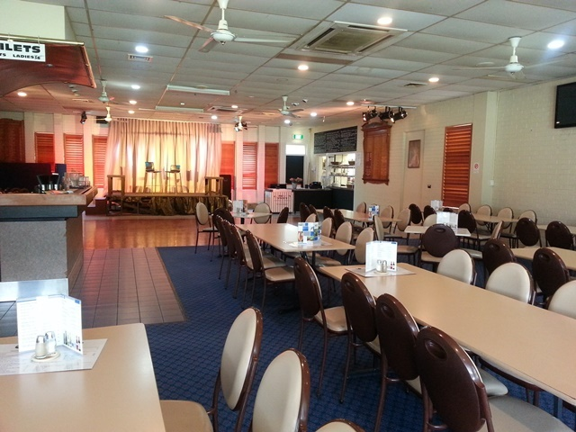 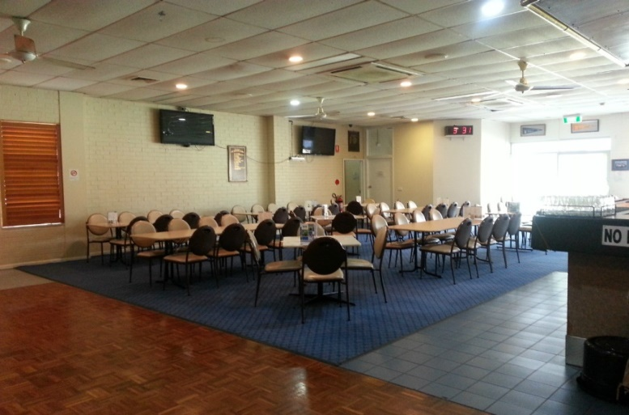

Our Function Room seats up to 100 guests or you can clear the tables and burn up the dance floor.

It is available Tuesday – Friday before 5pm, Saturday’s till midnight, Sunday before 5pm. The room is not completely private; we use office dividers to provide more privacy. We suggest you visit the venue to ensure it is suitable.

Due to noise restrictions on our Liquor License we do not permit DJ’s at the Club. We do allow soloist, duos, small bands etc., jukeboxes and karaoke. The noise limit will be tested during your event to ensure this rule is adhered to. We also have a system available to play your favourite tunes via USB. We suggest you test this before your event.

We have large televisions available for slideshows and a microphone available for speeches.

You are welcome to decorate the area as you wish and we will try to make the area available to you as early in the day as possible.

We welcome celebratory cakes and ask you bring your own serviettes, cutlery etc. to avoid cakeage charges.

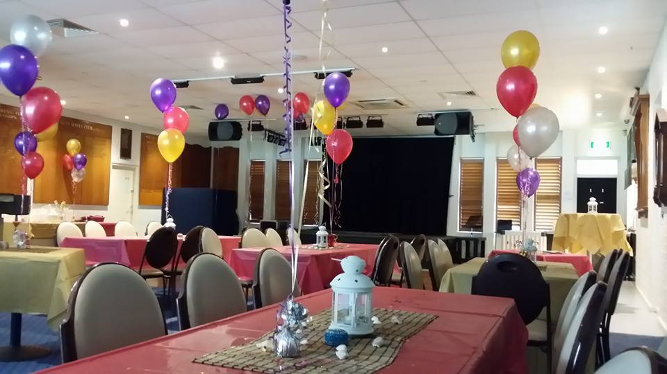 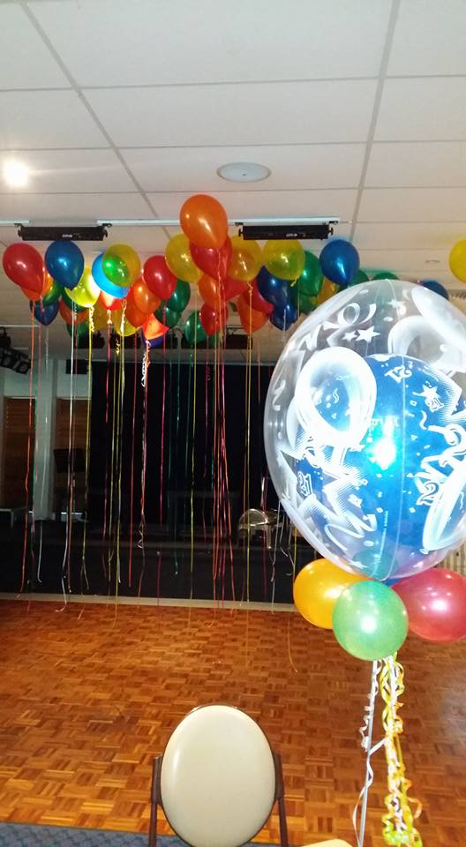

**Maroon on Brunswick**

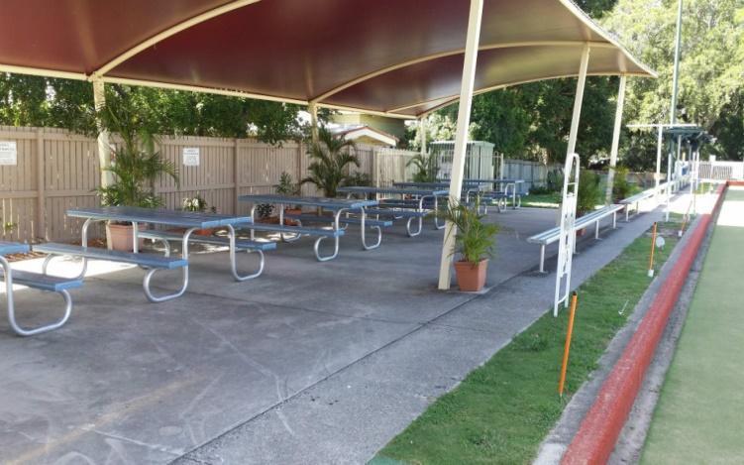 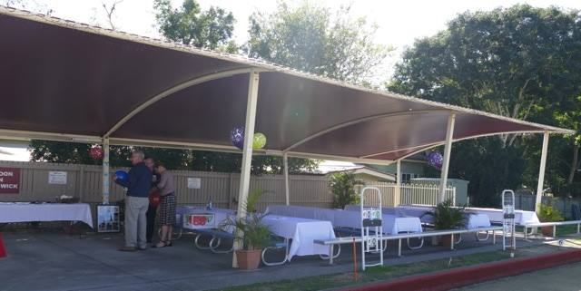

Maroon on Brunswick is situated at the far end of the Clubhouse on the Bottom Green and seats up to 80 guests.

It is available Tuesday till Saturday from 12 noon till 10pm (we ask you to bring your event indoors as we are in a residential area); Sunday from 12noon till 6pm.

Due to noise restrictions on our Liquor License we do not permit any amplified noise in this area.

You are welcome to decorate the area as you wish and we will try to make the area available to you as early in the day as possible.

We welcome celebratory cakes and ask you bring your own serviettes, cutlery etc. to avoid cakeage charges.

This is a non-smoking area.

**Veranda**

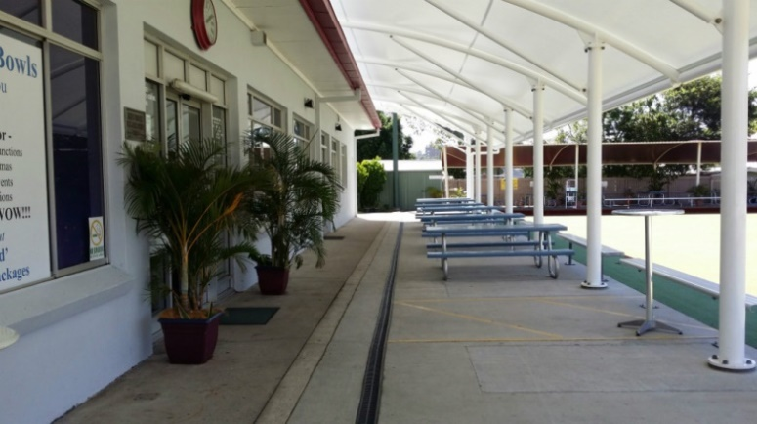 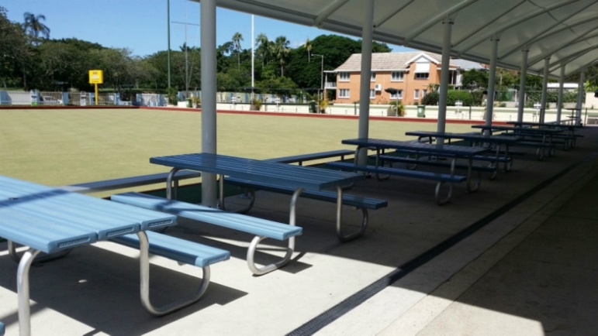

The Veranda is situated directly in front of the Clubhouse on the Bottom Green and seats up to 60 guests.

It is available Tuesday till Saturday from 12 noon till 10pm (we ask you to bring your event indoors as we are in a residential area), Sunday from 12noon till 6pm.

Due to noise restrictions on our Liquor License we do not permit any amplified noise in this area.

You are welcome to decorate the area as you wish and we will try to make the area available to you as early in the day as possible.

We welcome celebratory cakes and ask you bring your own serviettes, cutlery etc. to avoid cakeage charges.

This is a non-smoking area.

**View Deck**

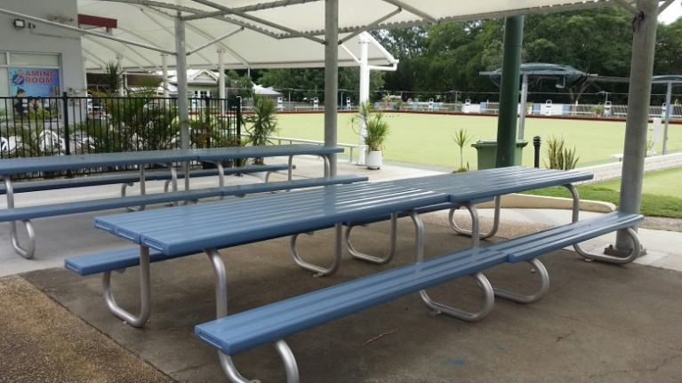 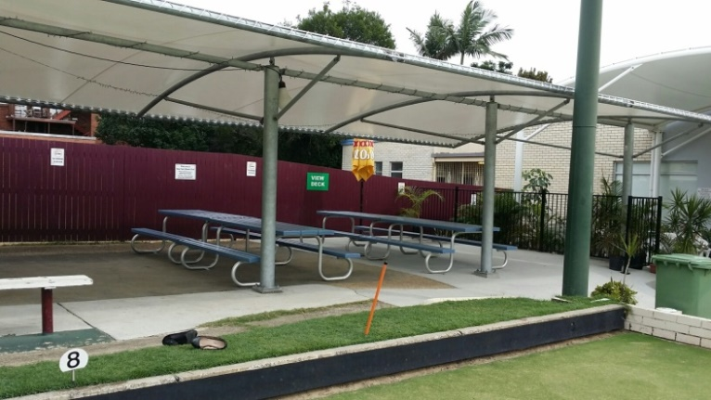

The View Deck is situated next to the Clubhouse on the Top Green and seats up to 50 guests.

It is available Tuesday till Saturday from 12 noon till 10pm (we ask you to bring your event indoors as we are in a residential area), Sunday from 12noon till 6pm.

Due to noise restrictions on our Liquor License we do not permit any amplified noise in this area.

You are welcome to decorate the area as you wish and we will try to make the area available to you as early in the day as possible.

We welcome celebratory cakes and ask you bring your own serviettes, cutlery etc. to avoid cakeage charges.

This is a non-smoking area.

**The Nook**

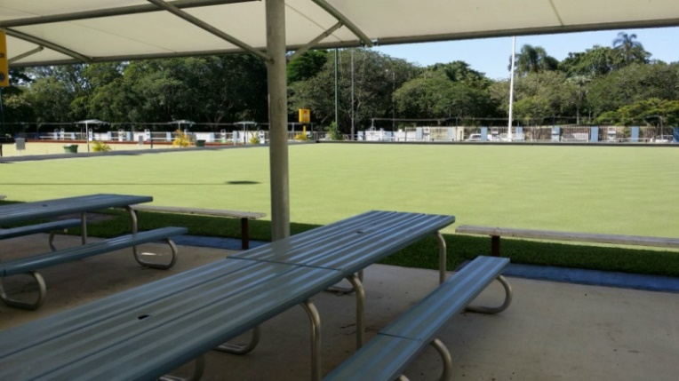 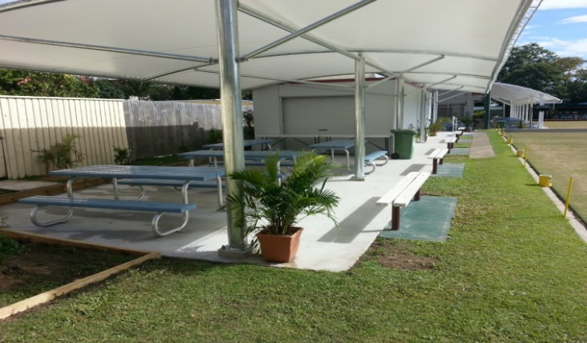

The Nook is situated at the top end of the Clubhouse on the Top Green and seats up to 40 guests.

It is available Tuesday till Sunday from 12noon till 5.30pm (we ask you to bring your event indoors/closer to the Club as we are in a residential area).

Due to noise restrictions on our Liquor License we do not permit any amplified noise in this area.

You are welcome to decorate the area as you wish and we will try to make the area available to you as early in the day as possible.

We welcome celebratory cakes and ask you bring your own serviettes, cutlery etc. to avoid cakeage charges.

This is a non-smoking area.

**DOSA – Designated Outdoor Smoking Area**

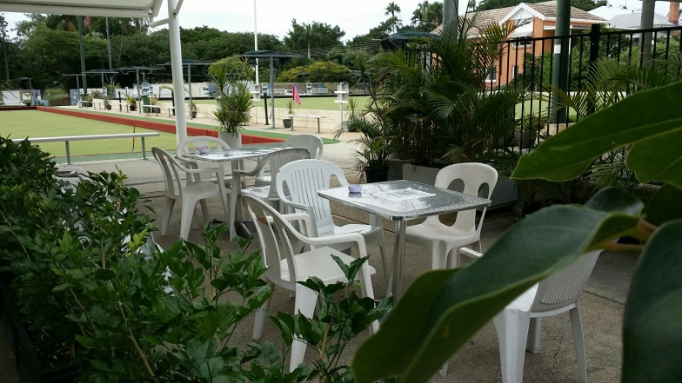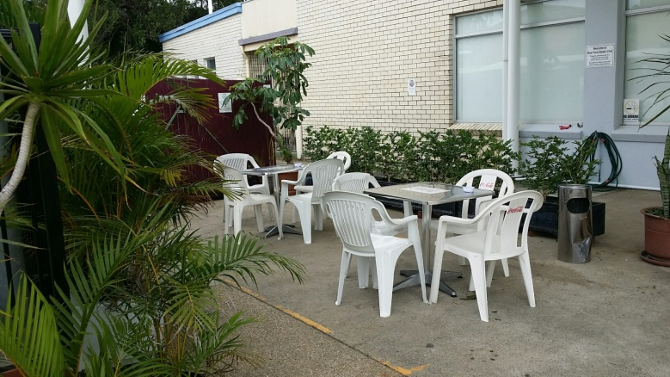

Our designated smoking area is situated next to the Clubhouse. No food is permitted in this area. We ask that you use the ashtrays provided.

A temporary designated smoking area can be set up if required near the Maroon on Brunswick area.

**Giant Games**

Other fun games can be added to your event at the hire fee $10 per game

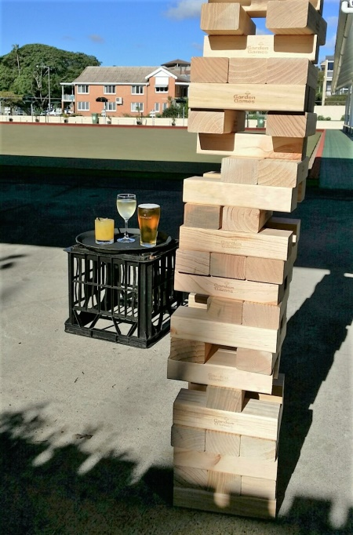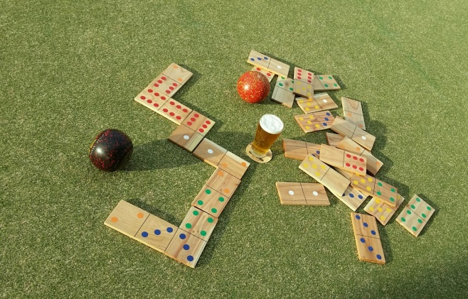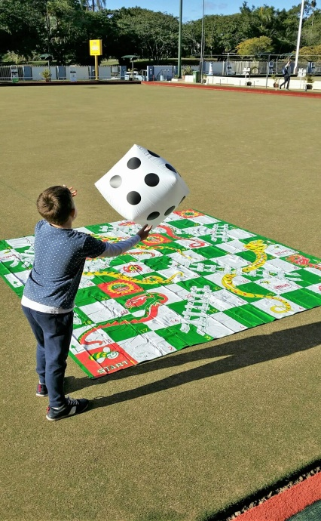

Catering

The New Farm Bowls Club offers a variety of catering options for your event from Platters for a cocktail style event to BBQ menus for the sit down style event. Our Chef can plan a special menu for your event if required. We cater for all dietary requirements. Please mention these at time of booking.

**Platters *C:\Users\User\AppData\Local\Microsoft\Windows\Temporary Internet Files\Content.IE5\IDHZ5UTY\MC900279848[1].wmf***

Our Platters are a great start to an event when bowling before your BBQ or as a nibble while you bowl.

Each platter serves up to 12p

***Trio of Dips***

*Homemade dips served with toasted turkish bread 40 V GF Available*

***Fresh Seasonal Fruit Platter*** *55 V****Cheese Platter*** *A selection of vintage cheddar, blue and brie cheeses,   
fruit paste, grapes, water crackers, dried fruit 75 GF Available*

***Sandwich Platter*** *A selection of gourmet sandwiches 65 GF & V Available*

***Antipasto Platter*** *A selection of olives, semi-dried tomatoes, roast   
capsicum, salami, prosciutto, salmon, pickles, feta   
cheese, artichoke hearts, pesto  
Served with toasted turkish bread & water crackers 75 GF & V Available*

***Hot Food Platter*** *Vegetable spring rolls & samosas, salt & pepper squid,  
tempura fish bites, mini dim sims & prawn twisters,*

*served with dipping sauces 75 V options****Party Pie Platter*** *An assortment of gourmet mixed party pies,   
mini quiches & sausage rolls with tomato &   
smoky bbq sauce 85 V Options****Dessert Platter*** *A yummy selection of cakes & slices served with   
fresh cream & strawberries 70 GF Available*

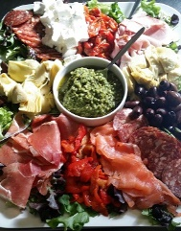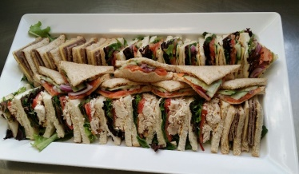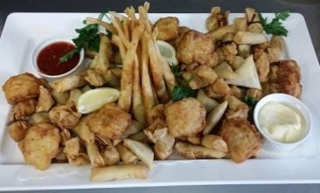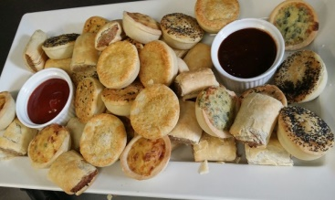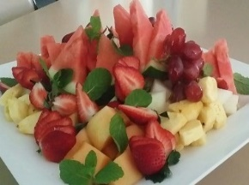

**BBQ’s** 

**BBQ’s are served buffet style and cooked especially for your group.**

**Functions less than 15 will be served plated to your table with a small salad buffet.**

**BBQ’s are not all you can eat (1 piece each item per person to ensure no one misses out).**

**BBQ’s outside Bistro hours may incur a surcharge.**

**BBQ’s are best enjoyed either before or after your bowls.**

***Kid’s BBQ (12 and under) $8.50 per child***

*Battered Fish* ***or***

*Chicken nuggets* ***or***

*Sausages*

*Served with chips and help yourself to salad selection on the buffet*

***BBQ 1 Menu – Minimum 10p******$23 per person***

*150gm Prime Rib Fillet*

*Gourmet Sausages*

*Chicken Teriyaki Skewers*

*Garden Salad*

*Crunchy Coleslaw*

*Penne Pasta Salad*

*Turkish Bread*

*Red Wine Gravy*

*Condiments*

***BBQ 2 Menu – Minimum 20p******$26.50 per person***

*As above - add*

*Marinated Prawn Skewers*

***Deluxe BBQ – Minimum 20p $45 per person***

***(Perfect for the corporate group)***

*Rocket & Parmesan Salad*

*Mediterranean Salad*

*Penne Pasta Salad*

*Eye Fillet Steak*

*Garlic & Thyme Lamb Skewers*

*Marinated Prawn Skewers*

*Chicken Teriyaki Skewers*

*Atlantic salmon*

*Turkish bread & condiments*

***Vegetarian options $25 per person***

*Roasted Vegetarian Lasagna*

*or*

*Spinach and Ricotta Cannelloni*

***Why Not add some yummy dessert?***

***Dessert Platters $70 each***

**Ala Carte Menu **

Tuesday – Friday Dinner from 6pm

***Italian Salad***

*mesclun, tomato, cucumber, red onion, roast capsicum,*

*olives, and egg with a lemon oregano dressing* ***$13.50***

***Waygu Burger***

*w/ cheese, onions, lettuce, tomato, relish, chips* ***$16***

***Chicken Burger***

*w/ cheese, bacon, lettuce, tomato, aioli, chips*  ***$16***

***Steak Sandwich***

*w/ cheese, onions, lettuce, tomato, chipotle aioli, chips* ***$16***

***Chicken Parmi***

*w/ chips & salad* ***$19.50***

***Fish & Chips***

*beer battered flathead w/ tartare sauce, lemon,*

*chips and salad* ***$17.50***

***Pasta of the Day***

*see the Specials board for today’s pasta dish*

***Atlantic Salmon***

*sumac encrusted Tasmanian salmon, sweet potato*

*mash, asian greens, and roast capsicum coulis* ***$22.50***

***Bangers and Mash***

*Pork, apple and sage sausages w/ garlic mash,*

*onion gravy and seasonal vegetables* ***$18.50***

***300g Porterhouse Steak***

*Rayner’s finest w/chips & salad* ***$24***

***Chips***

*w/ aioli, chipotle aioli or tomato sauce* ***$6***

***Olives***

*bowl of mixed olives in a Provencal marinade* ***$7***

***Sides******$5***

*mashed potato*

*mixed vegetables*

*salad*

***Add***

*bacon* ***$2***

*tomato sauce, aioli, chipotle aioli,*

*pepper sauce, mushroom sauce, gravy* ***$1.50***

***Kids Meal (12 and under)******$9***

*fish & chips*

*chicken nuggets & chips*

*spaghetti bolognaise*

***See the SPECIALS board for today’s specials!***

***Pat & Sticks Ice Cream Sandwich*** ***$5***

***Coffee/tea***

*cup* ***$3.50***

*mug* ***$4***

**All day Menu **

Friday & Saturday 12 noon till 6pm

***Waygu Burger***

*w/ cheese, onions, lettuce, tomato, relish, chips* ***$16***

***Chicken Burger***

*w/ cheese, bacon, lettuce, tomato, aioli, chips*  ***$16***

***Steak Sandwich***

*w/ cheese, onions, lettuce, tomato, chipotle aioli, chips* ***$16***

***Chicken Parmi***

*w/ chips & salad* ***$19.50***

***Fish & Chips***

*beer battered Flathead w/ tartare sauce, lemon,*

*chips and salad* ***$17.50***

***Chips***

*w/ aioli, chipotle aioli or tomato sauce* ***$6***

***Garden Salad $7.50***

***Pat & Sticks Ice Cream Sandwich*** ***$5***

**Bar Snacks Menu**

Tuesday to Sunday 12noon – 6 pm and Saturday 6 – 8pm

***Chips w tomato sauce $6***

***Sweet Potato Fries w aioli $9***

***Chicken Nuggets (5)*** *w chips & BBQ sauce* ***$9.5***

***Fish Bites (4)*** *w chips**& tartare sauce* ***$9.5***

***Salt & Pepper Squid (8)*** *w chips & aioli*  ***$9.5***

***Dim Sim (6)*** *w sweet chilli sauce* ***$6.5***

***Spring Rolls (6)*** *w sweet chilli sauce* ***$6.5***

***Prawn Twisters (5)*** *w sweet chilli sauce* ***$7.5***

***Four and Twenty Slammers $3.5***

***Four and Twenty Meat Pie $4***

***Four and Twenty Sausage Roll $3.5***

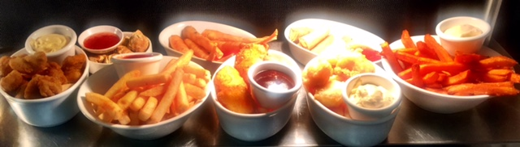

**Bar** 

The New Farm Bowls Club does not do drinks packages. You are welcome to start a bar tab informing us of your drinks choices for e.g. Beer/ Wine/ Soft drinks or Tap Beer/ House Wine Basic Spirits/ Soft drinks. There is no minimum spend. Your guests are also able to purchase their own beverages.

Prices are available upon request.

***TAP BEER*** *– XXXX Gold, Tooheys New, Hahn Super Dry, XXXX GOLD Pale Ale****,*** *James Squire 150 Lashes, James Squire Orchard Crush*

***CIDER*** *- Strongbow Cider, Sweet, Original, Dry, Bulmer’s, Rekorderling flavours 330ml*

***DOMESTIC STUBBIES*** *- XXXX Bitter, XXXX Gold, XXXX Summer, Hahn Ultra, Cascade Premium Light, Little Creatures (Pale Ale + Bright Ale), Rogers, Coopers Pale Ale, Coopers Sparkling Ale, Stone + Wood Pacific Ale, James Squire The Chancer/Four Wives/Swindler, Peroni, Peroni Leggera, Corona, Stella Artois, VB, Tooheys Old, Carlton Mid, Carlton Draught, Asahi, Heineken, Guinness Can.*

***SPIRITS*** *-**Basic spirit glass with mix*

***READY TO DRINK*** *- Bundy & Cola, Johnny Walker & Cola, Jim Beam & Cola, Jack Daniels & Cola, Smirnoff Red/Black, Canadian Club & Dry, Vodka Cruiser flavours*

***SOFT DRINK*** *– Coca-Cola Cans, Bundaberg Ginger Beer/Sarsaparilla, Mt Franklin Mineral Water, Mt Franklin Still Water, Red Bull, Powerade*

***HOUSE WINE***

*Oxford Landing Estate Sauvignon Blanc 2015 Waikerie, SA*

*Oxford Landing Estate Chardonnay 2015 Waikerie, SA*

*Oxford Landing Estate Merlot 2014 Waikerie, SA*

*Oxford Landing Estate Shiraz 2014 Waikerie, SA*

*Gossips Sweet Moscato South East Australia*

***SPARKLING WINE***

*Redbank Emily Pinot Noir Chardonnay Brut Cuvee Piccolo NV King Valley, Vic*

*Redbank Emily Pinot Noir Chardonnay Brut Cuvee NV King Valley, Vic*

*Angus Brut Premium Cuvee/Moscato NV South Australia*

*Jansz Premium Non Vintage Cuvee NV Tasmania*

*Pol Roger Brut Non Vintage NV Epernay, France*

***WHITE WINE***

*Redbank ‘The Long Paddock’ Sauvignon Blanc 2015 Victoria*

*O’Leary Walker Blue Cutting Road 2014 Clare Valley, SA*

*Yalumba Y Series Pinot Grigio 2015 South Australia*

*Pitchfork Chardonnay 2015 Margaret River, WA*

*Jim Barry Lavender Hill Reisling 2015 Clare Valley, SA*

*Twin Islands Sauvignon Blanc 2015 Marlborough, NZ*

*Mawsons Sauvignon Blanc 2015 South Australia*

***RED WINE***

*West Cape Howe Rose 2015 Mt Barker, WA*

*Haha Pinot Noir 2014 Marlborough, NZ*

*Mawson’s Cabernet Sauvignon 2013 South Australia*

*Yalumba ‘Patchwork’ Shiraz 2013 Barossa, SA*

*Redbank Merlo 2014 Coonawarra, SA*

*Running with the Bulls Tempranillo 2014 Barossa, SA*

*The Barry Bros. Shiraz Cabernet Sauvignon 2014 Clare Valley, SA*

*Year may change without notice*

Terms and conditions 

1. Deposit

An invoice will be issued upon booking for all events requiring catering. A deposit of $200 is required to secure your booking. For bookings over 50pp or for Deluxe BBQ’s, $500 will be requested. The deposit amount will be debited from the balance of your invoice.

2. Payment

Final numbers and full payment (balance of invoice) is required **3 working days** prior to event (see point 3). For large groups, payment may be required 7 working days prior to event. Changes to numbers after this time must be approved by management. Payment can be made by cash, credit card, eftpos, direct deposit and company cheque. Amex accepted with 3.5% surcharge. No diners.

3. **October, November and December**

A deposit of $100 is required to hold your booking.

**Final numbers and full payment during this time is required 7 working days prior to your event.**

4. Cancellations

Notice of cancellation made 30 days prior to event will receive a full refund of deposit, 14 days prior will receive 90% of deposit, and 7 days prior will receive 50% of deposit. Cancellations made after this time will forfeit deposit.

If cancellation is made by the Club, due to weather or other unforeseen circumstances, a full refund of the barefoot bowls component will be received. Catering cannot be cancelled due to weather. The Club is still open for you to enjoy the great food and the company of your guests.

5. Event Timing

It is the customer’s responsibility to ensure that their planned event runs on time. The Club will not be held responsible when guests are not punctual for the event. When barefoot bowls starts late, the specified finish time will still apply. BBQ’s must be served at your specified time. Please try to arrive at least 15mins before your event starts.

6. Minors

New Farm Bowls Club is family friendly and welcomes children bowlers (we have smaller bowls for the smaller kids). Children must be supervised at all times by a parent or carer. Minors are not permitted at the bar or in the Gaming Room. Alcohol will not be served to minors and proof of age will be asked for if necessary (failure to prove proof of age may result in refusal of service).

7. Music

New Farm Bowls Club does not permit any amplified noise in our outdoor areas due to Liquor Licensing restrictions.

8. Behavior

New Farm Bowls Club is situated within the neighborhood and we ask that you respect our neighbors both whilst at the Club and on departure. New Farm Bowls Club does not tolerate disorderly or drunken behavior, and said patrons will be asked to leave the venue. Refusal to do so may incur a fine.

*‘A copy of the Privacy Policy of New Farm Bowls Club Inc. is available on our website. By signing this agreement, you acknowledge that you have read and agree to the terms of the privacy Policy of New Farm Bowls Club Inc.’*

**Terms and Conditions agreement**

**I, _____________________________________________ (print name) have read and agree to the Terms and conditions stated above for my event planned for ___________________ (Function date).**

**Signature: ________________________________ Date: ________________________________**

**Booking Form**

**Please fill in all areas and return to** [**functions@newfarmbowls.com.au**](mailto:functions@newfarmbowls.com.au) **or Fax (07)3254 0074**

**\*Form only required when catering is required**

Booking Name: ______________________________________________________________

Booking date: ________________________________________________________________

Company Name: _____________________________________________________________

Contact phone number: _______________________________________________________

Email address: ________________________________________________________________

Contact person at event (if not same as booking name): ______________________________

Preferred Area: _______________________________________________________________

Barefoot Bowls session: ________________________________________________________

Barefoot Bowls rinks: __________________________

Catering requirements:

**BBQ’s** Please circle

BBQ 1 BBQ 2 Deluxe BBQ

Number of Adults: ______ Time of BBQ: ______**Please note your BBQ will be served at this time**

Kids BBQ Battered Fish x _______ Sausage x _____________ Nuggets x ______________

Vegetarians x ___________ Other Dietary requirements: ____________________________

__________________________________________________________________________________

**Platters**

Trio of Dips x __________ Fresh Fruit x ___________ Antipasto x __________

Large Cheese x ________ Fresh Sandwich x ________ Hot Food x _____________

Gourmet Party x ________ Dessert x ____________

Time for platters: ________________________________________________

**Payment Details**

Preferred option

* Direct Deposit BSB 034065 ACC# 232529 ACC NAME New Farm Bowls Club Inc.

Please quote invoice number as reference and forward remittance advice to [functions@newfarmbowls.com.au](mailto:functions@newfarmbowls.com.au)

* Credit Card

Please debit my Credit Card

MasterCard Visa Amex Please note a surcharge of 3.5%

Amount: $______________ Please circle Deposit Payment in full

Card number: __ __ __ __-__ __ __ __-__ __ __ __-__ __ __ __ Expiry Date: _____/_____

CCV: __ __ __ 3 digit number on back of card Name on card: _______________________

Signature: ____________________________________ Date: ___________________________

*‘A copy of the Privacy Policy of New Farm Bowls Club Inc. is available on our website. By signing this agreement, you acknowledge that you have read and agree to the terms of the privacy Policy of New Farm Bowls Club Inc.’*