Searching for participants MyNetball ID

To purchase a Netball Victoria Membership Registration the participant is required to log into their MyNetball account by using their MyNetball Login ID and Password.

The participants Login ID will either be an ‘Email Address’, or ‘Netball Victoria Membership Number’ (ID number). Club Administrators can search for a participants Login ID through their MyNetball Administration access.

1. Visit admin-netball.resultsvault.com and then login by using your MyNetball Administration Username and Password.

Or visit www.aflgoulburnmurray.com.au, select the ‘Netball’ tab, then ‘GVL Netball’. Select ‘Club Resources’ tab, then ‘MyNetball Administration’. Login by using your MyNetball Administration Username and Password.

2. Once logged in, select ‘PEOPLE’ from the top tool bar

3. On the left-hand side, select ‘Participant Login Manager’ and add the participants First and Last Name in the fields, then select Filter.

4. Under Login ID will either list an ID Number or Email Address. This is the required Login ID to be used for that participant.

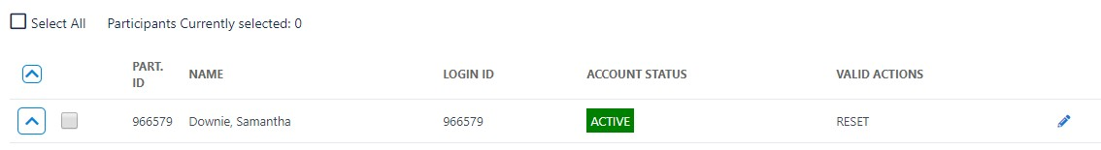ID Number (example):

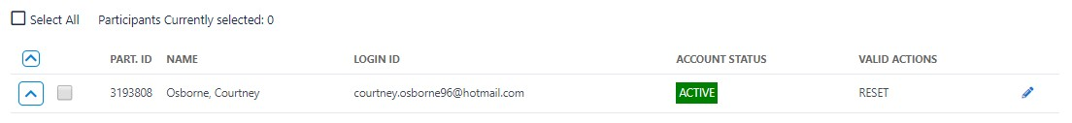Email Address (example):

