UNSW/ES Stingrays Scholarship Offer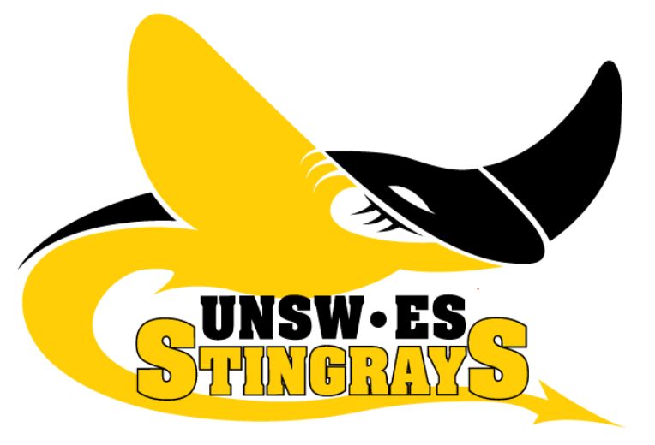
The UNSW/Eastern Suburbs Stingrays have competed in the AFL Sydney Women’s Competition since its inaugural year back in 2001. We train at the Village Green at the University of NSW and the National Centre for Indigenous Excellence in Redfern. Our 2016 home ground will be announced shortly.
The Stingrays were the first club to field teams in both divisions of the Sydney competition. Having two teams provides a fantastic opportunity to develop your skills and train with a range of players.
The Division One team (now called Premier Division) made the Preliminary Final in 2015 and the Grand Final in 2014, and the Division Two team (now called Division 1) narrowly missed out on the final series in their first year of competition.
We have a dedicated coaching staff including our Head Coach, Tracey Kick (2015 Assistant Coach of the NSWACT inaugural combined state team and formerly NSW Women’s Coach), Assistant Coach, Ben Porter and Division 1 Coaches Kate Edwards and Jemma Still.
In 2016, UNSW/ESAFC is delighted to offer three youth / development scholarships valued at over $350 each for females aged between 17 and 20. Priority will be given to applicants who have not previously played a season with the Stingrays.
The scholarships cover the following:
• Free registration
• Free uniform and team merchandise
• An allocated mentor (senior or NSW state player)
Applications are now open, and will close on Friday 11th March.
To apply for the scholarship, please complete this online form https://www.surveymonkey.com/r/TVFZSZQ
Applications will be assessed by the UNSW/ESAFC Coaching Panel and individuals will be contacted directly by the club. Prior experience playing AFL is preferred, however not essential.
For more information, please email the club at unsw.stingrays@gmail.com.

