Albury Basketball Association 2020 Basketball Trials!
TRIAL 1 - Sunday 13th October 2:00pm to 5:00pm – Lauren Jackson Sports Centre
U12 Boys & Girls (Born 2009/2010/2011) 2:00pm to 3:30pm
U14 Boys & Girls (Born 2007/2008) 2:00pm to 3:30pm
U16 Boys & Girls (Born 2005/2006) 3.30pm to 5:00pm
U18 Boys & Girls (Born 2003/2004) 3.30pm to 5:00pm

TRIAL 2 - Sunday 20th October 12:30pm to 5:00pm – Wodonga Sports & Leisure Stadium
U12 Boys & Girls & (Born 2009/2010/2011) & U14 Boys (Born 2007/2008) 12:30pm to 2:00pm
U14 girls (Born 2007/2008) & U16 Boys & Girls (Born 2005/2006) 2.00pm to 3:30pm
U18 Boys & Girls (Born 2003/2004) 3.30pm to 5:00pm

TRIAL 3 - Sunday 20th October 9:00am to 6:00pm – Wodonga Sports & Leisure Stadium
U12 Boys (Born 2009/2010/2011) 9:00am to 10:30am U16 Boys Born (2005/2006) 3.00pm to 4:30pm
U12 Girls (Born 2009/2010/2011) 10:30am to 12:00pm U16 Girls Born (2005/2006) 3.00pm to 4:30pm
U14 Boys (Born 2007/2008) 12:00pm to 1:30pm U18 Boys Born (2003/2004) 4.30pm to 6:00pm
U14 Girls Born (2007/2008) 1:30pm to 3:00pm U18 Girls Born (2003/2004) 4.30pm to 6:00pm

Do you want to?

Play Basketball in the NSW Basketball Waratah League Country competition

Have the opportunity to be identified for elite BNSW programs

Learn from the best coaches, in a learning environment, that has a clearly stated development curriculum called “The Cougars Way”

Make great friendships with like-minded, motivated kids

IMPORTANT – Please do not wear Albury Cougars, Basketball NSW Country or Basketball NSW apparel to try-outs.
Domestic singlets and shore allowed or comfortable clothes for basketball training purposes.
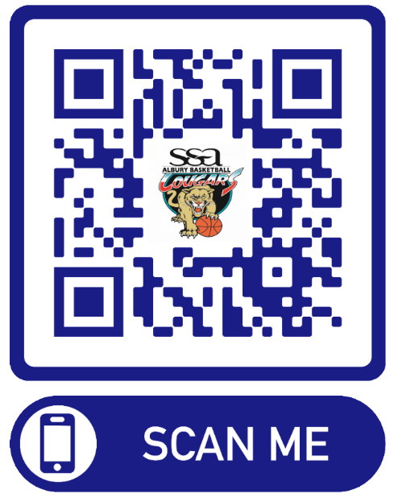
All players attending trials
- Please complete and sign the “online ABA Cougars intention to trial form” (due 9 OCT) Simply scan the QR Code provided or visit our ABA website http://albury.basketball.net.au

- Will be required to pay $15 cash on arrival to trial (covers court hire for the three days)

- Are asked to please arrive 15 minutes prior to the scheduled start, dressed in Basketball playing/training gear including mouth guard, and any personal strapping if required.(You should use this time to warm up and stretch)

Please bring a basketball, water bottle, and any medication (Asthma puffers, etc.) clearly marked with your name if needed.
For more info:
Email: admin@alburybasketball.com.au
Visit our website: http://albury.basketball.net.au

