Warm up top Sponsorship Opportunity

Each junior team for the 2017/18 season is seeking up to 4 sponsors for the back of their team warm up top.

For as little as $250 your business could be proudly supporting a Warrior junior team for the next 12 months and longer.

Option 1 = ¼ advertisement for $250 Option 2 =1/2 advertisement for $500

Option 3 =3/4 advertisement for $750 Option 4 = entire back of warm up top for $1000

Front Back
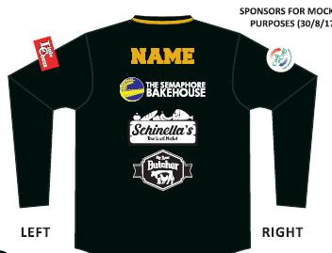
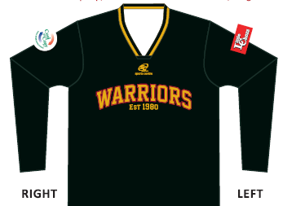

To book your place please fill out this form and send it to Kendi Whitmore
Email: whitmorekendi@gmail.com Mobile: 0431 191 192
Company Name…………………………………………………… Contact person ……………………………………..
Email: Contact Number:
Sponsor Option: (please circle) 1 2 3 4
Payment option: (please Circle) Cash Credit Card Cheque Direct debit
Do you need a tax invoice: YES/NO
Team you are supporting: e.g. Under 12 boys Div 2:
Player/s you are connected to in that team:
Please be aware you will need to supply a High resolution copy of your business logo.

