Double crossers

By David Clarke
Scoring from crosses is something every team needs to practise. Rather than just a "hit and hope", successful crosses involve skill, timing and teamwork.
A cross is like an accurate long pass - it needs to be aimed at a specific area. The end focus of this session is the timing of a run and the execution of a shot, but it requires a good pass in the first place.
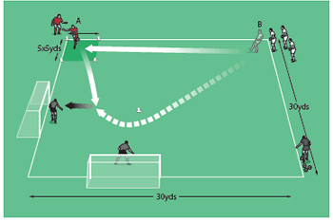
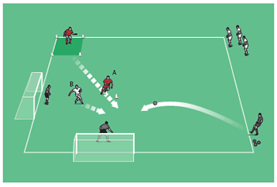
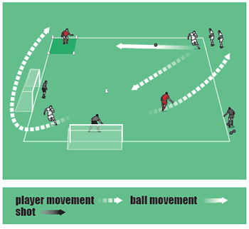

How to play it
- For this practice, you will need lots of balls, two goals, two keepers and a server.
- Set up as shown in the top picture – a 20-yard square with a five-yard box at the top left of the area. There are players in the top left and top right corners, and two goals in the bottom left corner. The goals are at right angles to each other, and seven yards in from the corner. There is also a cone near the centre of the area.
- To start, B passes to A, then makes a run around the cone to receive the ball back from A, then fires at goal.
- Whether or not the chance ends up being taken, A moves towards the other goal, looking to get on the end of a cross from the server (see the middle picture). B must defend 1v1, attempting to prevent a goalscoring chance.
- At the end of that move, B goes to A's initial position at top left while A goes to the group at top right (see the bottom picture).
- Now the next players in line take their turn.

Advancing the session
- Try putting conditions on the types of crosses. For instance, A crosses for a header, while the server crosses for a shot on the ground.
- Alternatively, a good way to make the practice more competitive is to add a defender in front of each goal.

Technique and tactics
- This is a simple but effective practice that requires positive running with good timing.
- Crosses must be precise – and practice makes perfect in this respect, so ensure you run this through a few times so that players can master the art.

