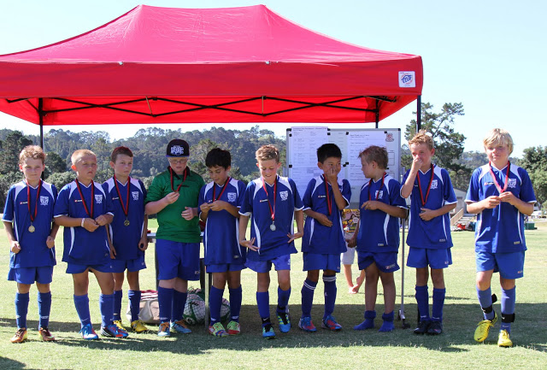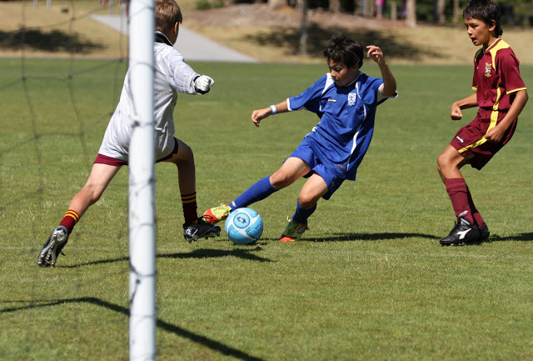
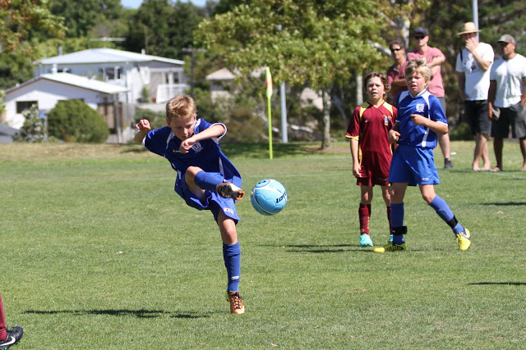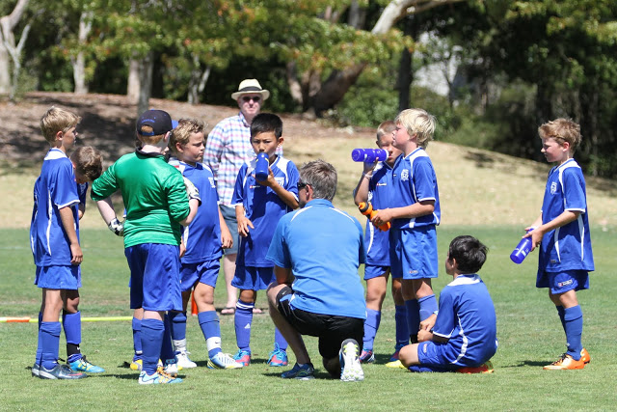
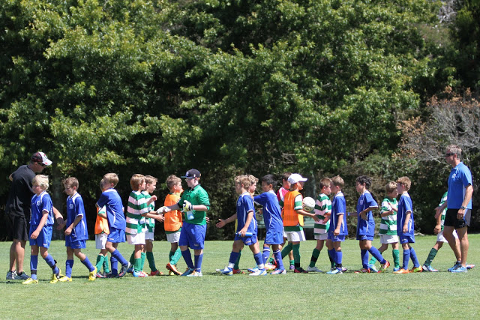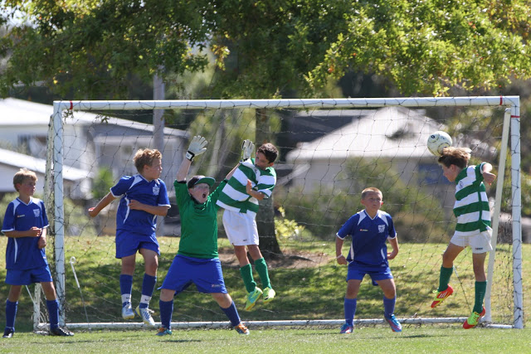
What an awesome start for our new 10th grade A team and Giles Hoy (coach) at the pre season children’s tournament at Birkenhead United on Sunday 10 March. Excellent team work, some fancy foot work, top goals and great defending, found the team in the final. After a full day of playing in the sun and being taken out by a mini tornado, the boys lost the final to Western Springs. Top results in coming second, well done the 10th Grade A Team.

