COUNTIES MANUKAU ZONE OF NZRL INC
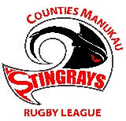
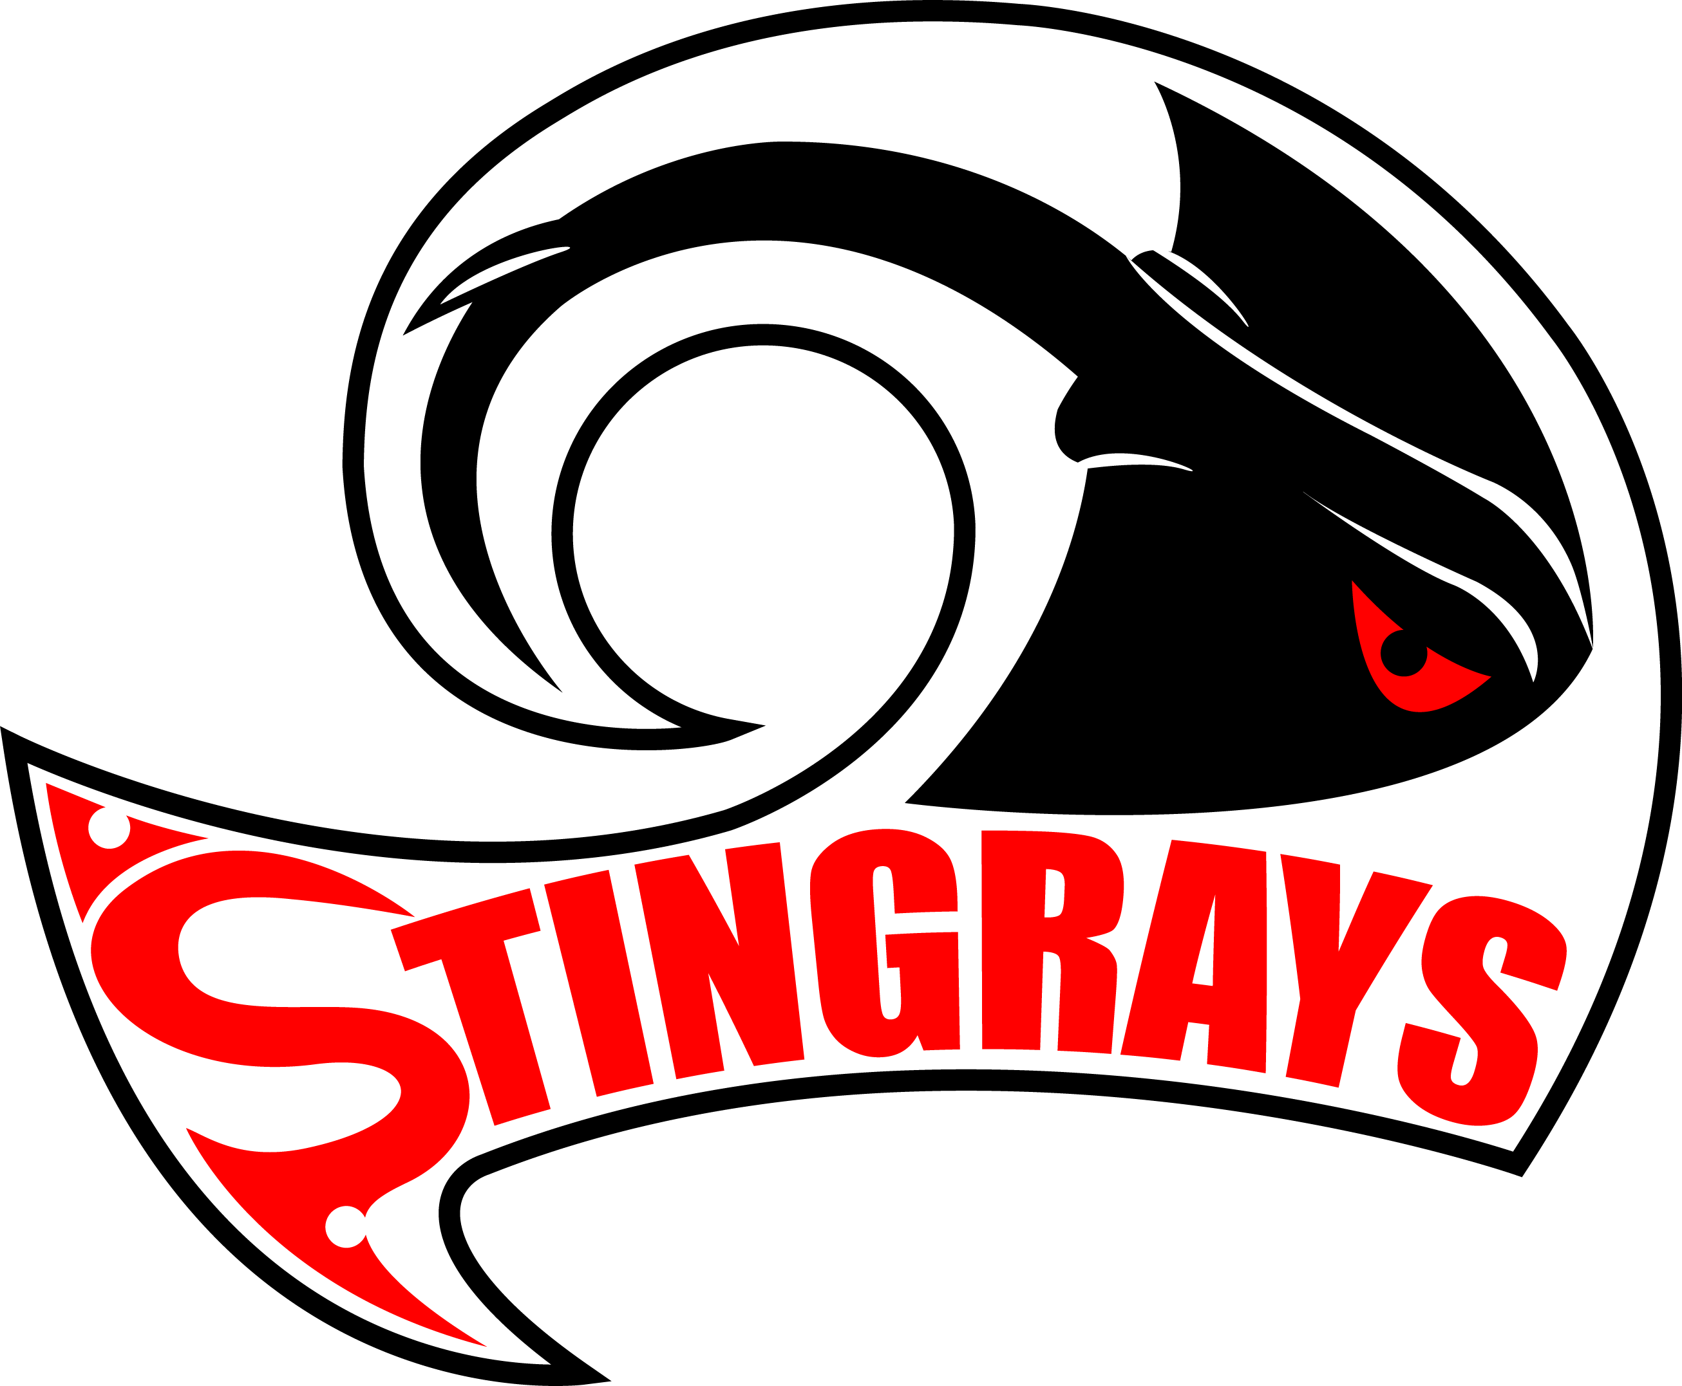

MEMO TO ALL CLUBS

29th July 2016

RE: 15s STINGRAYS FINAL SQUAD

The following Players have been selected to represent
Counties Manukau Zone
15s Stingrays at the 2016 NZRL National Youth Tournament.

# | PLAYER | CLUB
1 | Diaz Taihia | Mangere East
2 | Xavier Stevens-Teo | Mangere East
3 | Keanu Mann | Mangere East
4 | Paea Fotu | Mangere East
5 | Tenapi Waipouri | Mangere East
6 | Aamon Dean | Otahuhu
7 | Fred Taomaletoa | Otahuhu
8 | Semisi Sikei | Otahuhu
9 | Sam Taunga | Otahuhu
10 | Setala Setala | Otahuhu
11 | Semisi Tapa | Otahuhu
12 | Etuale Lui Toeava | Otahuhu
13 | David Aofia | Otahuhu
14 | Mathew Palu | Otahuhu
15 | Talitua Salima-Safuia | Otahuhu
16 | Kaya Cuthers | Otahuhu
17 | Manase Fakaosilea | Otahuhu
18 | Hurricain Roberts | Manurewa
19 | Sirila (Steven) Ioelu | Otara
20 | Marco Talagi | Otara
21 | Paea Vunipola | Otara
22 | Brian Lealiifano | Otara

OFFICIALS Mike Cudd Head Coach
Jay Upoko Assistant Coach
Tania Harris Manager
Josh Naidu Trainer
Allan Horn Physio

