NEW FARM BOWLS CLUB
FUNCTIONS PACK
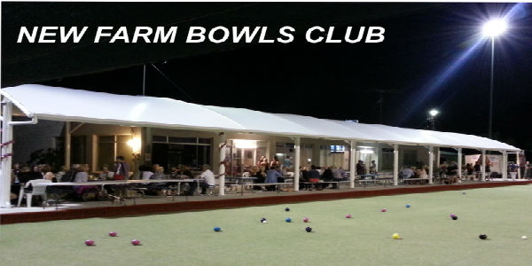
Opening times
Bar Kitchen
Monday: Closed Closed
Tuesday: 12noon till late Dinner from 5pm Bar Snacks 12-6pm
Wednesday: 12noon till late Dinner from 5pm Bar Snacks 12-6pm
Thursday: 12noon till late Dinner from 5pm Bar Snacks 12-8pm
Friday: 12noon till late Lunch from 12noon Dinner from 5pm Bar Snacks 12-6pm
Saturday: 10am till late Lunch from 12noon Dinner from 5pm Bar Snacks 12-8pm
Sunday: 12noon till 6pm Lunch from 12noon Bar Snacks 12-6pm

Location
New Farm Bowls Club is positioned directly opposite the beautiful New Farm Park at 969 Brunswick St.
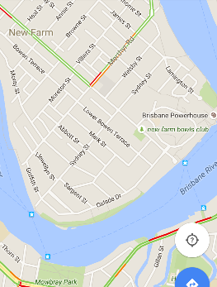
Public Transport is the best way to travel to the Club with Bus 196 at the front of the Club and City cat/Ferry terminal 100m at the end of Brunswick St. unfortunately the Club does not have a car park but all street parking in the area is unmetered.
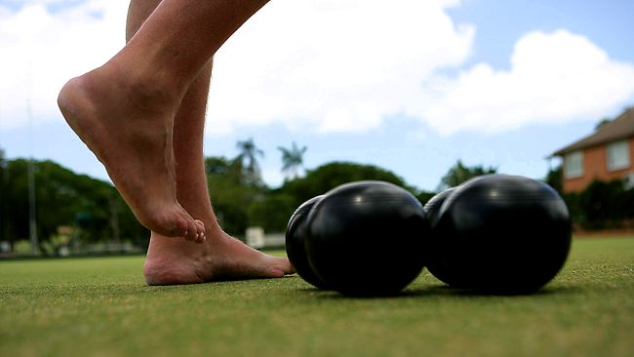
Barefoot Bowls

Monday N/A
Tuesday 11 -1pm, 1-3pm, 3-5pm, 5-7pm, 7-9pm.
Wednesday 11-1pm, 1-3pm, 3-5pm, 5-7pm, 7-9pm.
Thursday 11-1pm, 1-3pm, 3-5pm, 5-7pm, 7-9pm.
Friday 11-1pm, 1-3pm, 3-5pm, 5-7pm, 7-9pm.
Saturday 11-1pm, 1-3pm, 3-5pm, 5-7pm, 7-9pm.
Sunday 11-1pm, 1-3pm, 3-5pm, 5-7pm, 7-9pm.

The cost of barefoot bowls is $8pp before 5pm and $10pp after 5pm.
In October, November and December barefoot bowls is charged at $80 per rink, up to 8 bowlers per rink.
The 7-9pm session is not available during the months of May, June, July.
The price includes equipment, 2 hours of bowling plus instructions and tips from our barefoot bowls coordinators.
You are more than welcome to come as early and stay as late as you wish. The times stated are your ‘on the green’ times. Times can be flexible certain times of the year.
Kids of all ages are welcome. Cost $5 under 12.

The following rules are to be observed at all times:
- Bare feet only on the greens (socks are permitted)
- Children are to be supervised at all times
- No eating, drinking or smoking on the greens (drinks can be carried to the other end when necessary)
- No sitting on the edge of the greens
- Definitely no driving

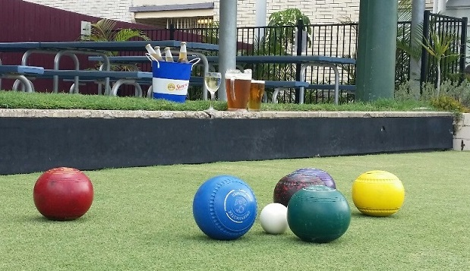
Function Areas
Function Room hire $100
Function Room
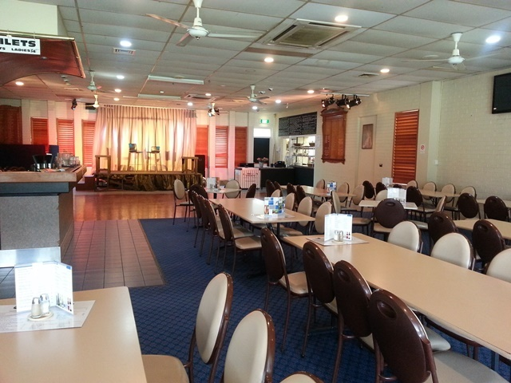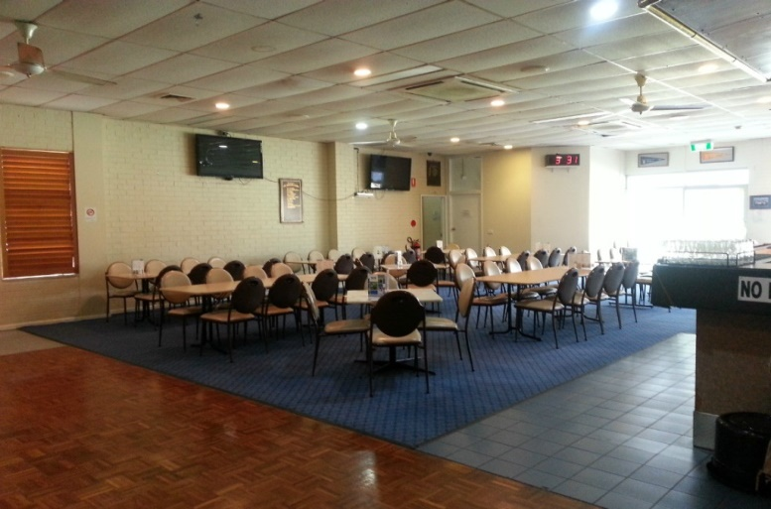
Our Function Room seats up to 100 guests or you can clear the tables and burn up the dance floor.
It is available Tuesday – Friday until 5pm, Saturday’s till midnight, Sunday until 5pm. The room is not completely private; we use office dividers to provide more privacy. We suggest you visit the venue to ensure it is suitable.
Due to noise restrictions on our Liquor License we do not permit DJ’s at the Club. We do allow soloist, duos, small bands etc., jukeboxes and karaoke. The noise limit will be tested during your event to ensure this rule is adhered to. We also have a system available to play your favourite tunes via USB. We suggest you test this before your event.
We have large televisions available for slideshows and a microphone available for speeches.
You are welcome to decorate the area as you wish and we will try to make the area available to you as early in the day as possible.
We welcome celebratory cakes and ask you bring your own serviettes, cutlery etc. to avoid cakeage charges.
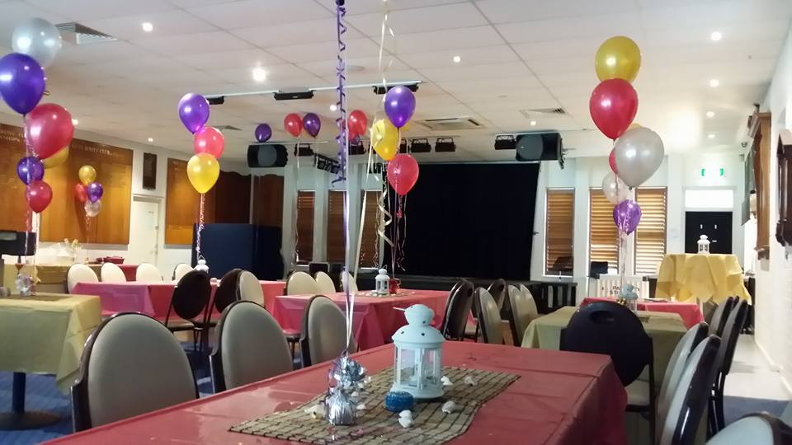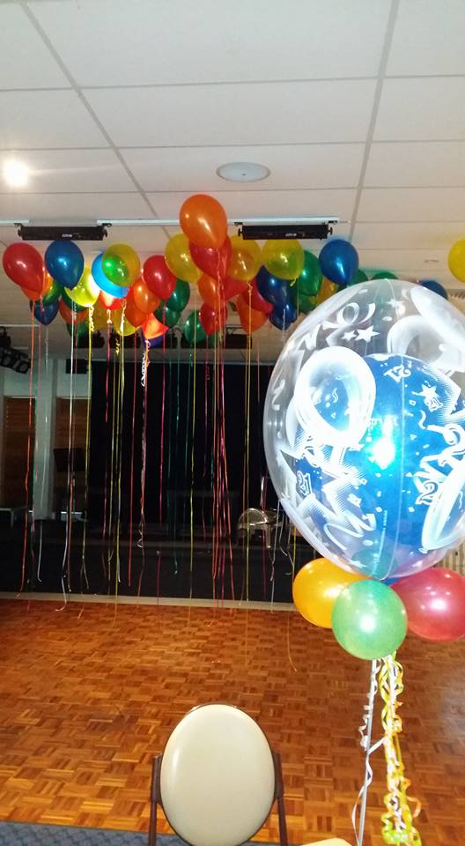
Maroon on Brunswick

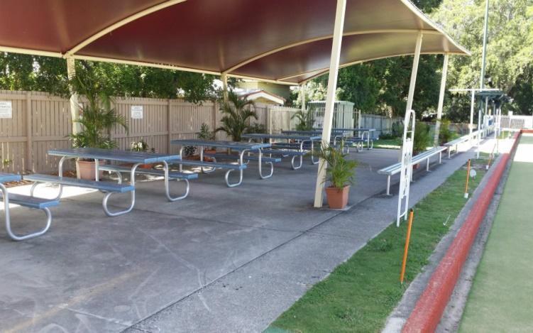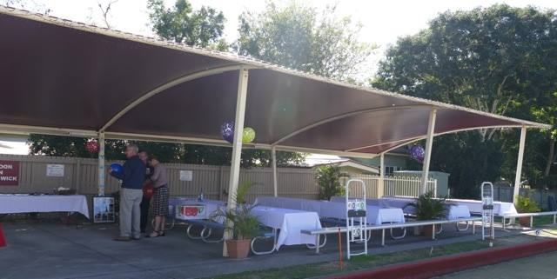
Maroon on Brunswick is situated at the far end of the Clubhouse on the Bottom Green and seats up to 80 guests.
It is available Tuesday till Saturday from 12 noon till 10pm (we ask you to bring your event indoors at 10pm as we are in a residential area); Sunday from 12noon till 6pm.
Due to noise restrictions on our Liquor License we do not permit any amplified noise in this area.
You are welcome to decorate the area as you wish and we will try to make the area available to you as early in the day as possible.
We welcome celebratory cakes and ask you bring your own serviettes, cutlery etc. to avoid cakeage charges.
This is a non-smoking area.

Veranda

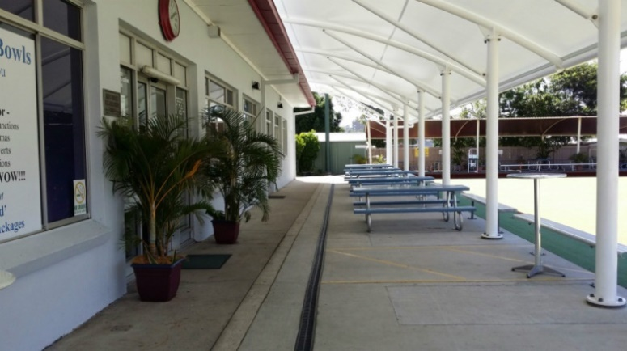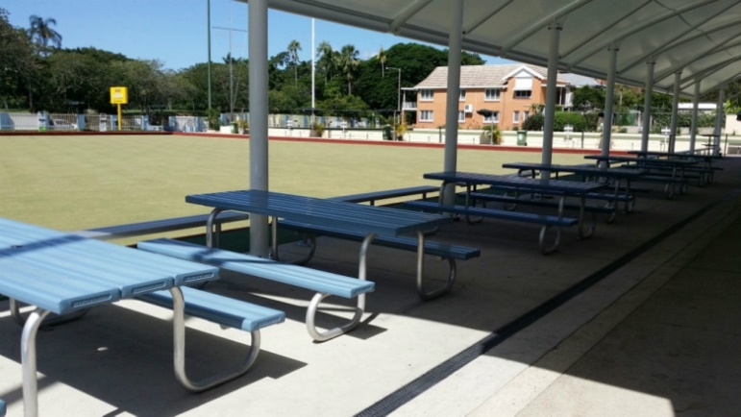
The Veranda is situated directly in front of the Clubhouse on the Bottom Green and seats up to 60 guests.
It is available Tuesday till Saturday from 12 noon till 10pm (we ask you to bring your event indoors at 10pm as we are in a residential area), Sunday from 12noon till 6pm.
Due to noise restrictions on our Liquor License we do not permit any amplified noise in this area.
You are welcome to decorate the area as you wish and we will try to make the area available to you as early in the day as possible.
We welcome celebratory cakes and ask you bring your own serviettes, cutlery etc. to avoid cakeage charges.
This is a non-smoking area.

View Deck

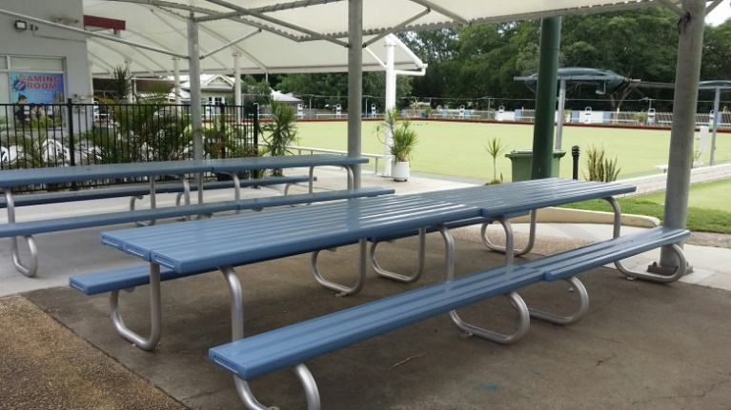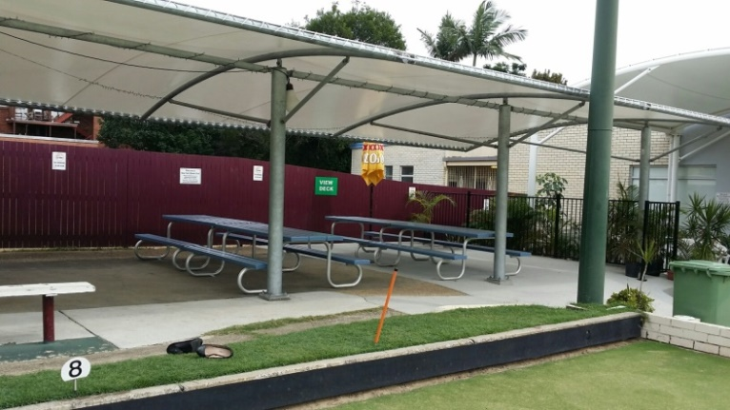
The View Deck is situated next to the Clubhouse on the Top Green and seats up to 50 guests.
It is available Tuesday till Saturday from 12 noon till 10pm (we ask you to bring your event indoors at 10pm as we are in a residential area), Sunday from 12noon till 6pm.
Due to noise restrictions on our Liquor License we do not permit any amplified noise in this area.
You are welcome to decorate the area as you wish and we will try to make the area available to you as early in the day as possible.
We welcome celebratory cakes and ask you bring your own serviettes, cutlery etc. to avoid cakeage charges.
This is a non-smoking area.

The Nook

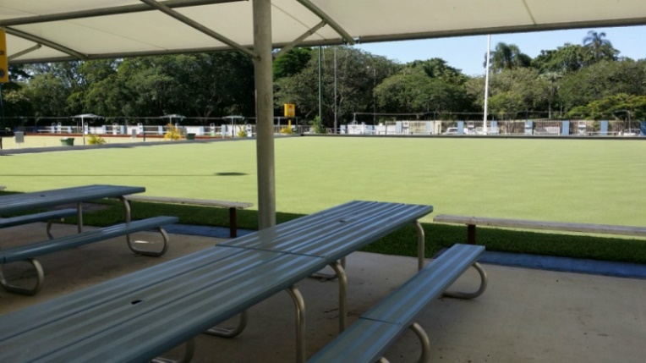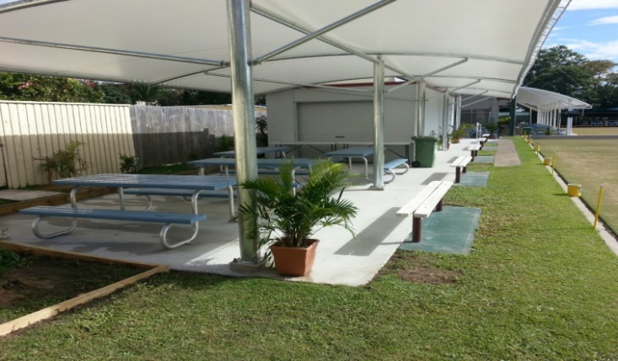
The Nook is situated at the top end of the Clubhouse on the Top Green and seats up to 40 guests.
It is available Tuesday till Sunday from 12noon till 5.30pm (we ask you to bring your event indoors/closer to the Club at 5.30pm as we are in a residential area).
Due to noise restrictions on our Liquor License we do not permit any amplified noise in this area.
You are welcome to decorate the area as you wish and we will try to make the area available to you as early in the day as possible.
We welcome celebratory cakes and ask you bring your own serviettes, cutlery etc. to avoid cakeage charges.
This is a non-smoking area.

DOSA – Designated Outdoor Smoking Area

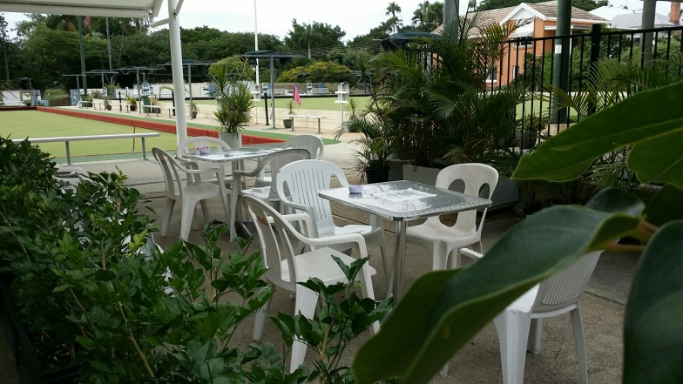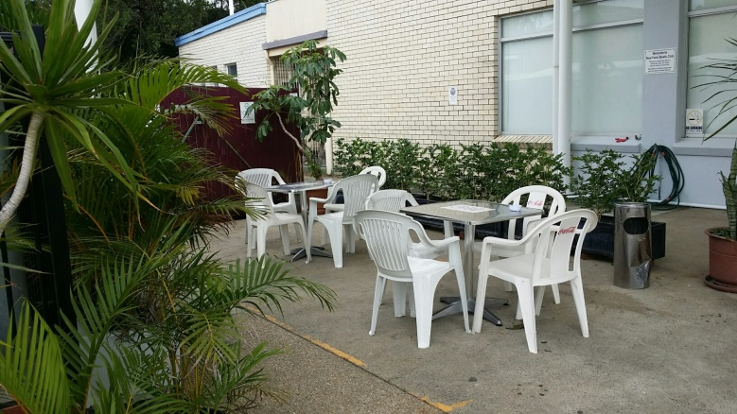

Our designated smoking area is situated next to the Clubhouse. No food is permitted in this area. We ask that you use the ashtrays provided.
A temporary designated smoking area can be set up if required near the Maroon on Brunswick area.

Giant Games
Other fun games can be added to your event at the hire fee $10 per game
Jenga, Dominos, Snakes & Ladders, Connect 4

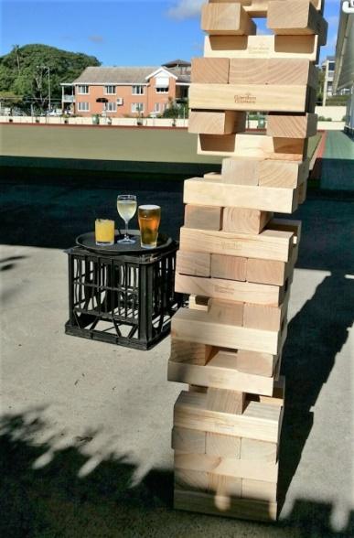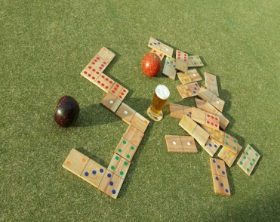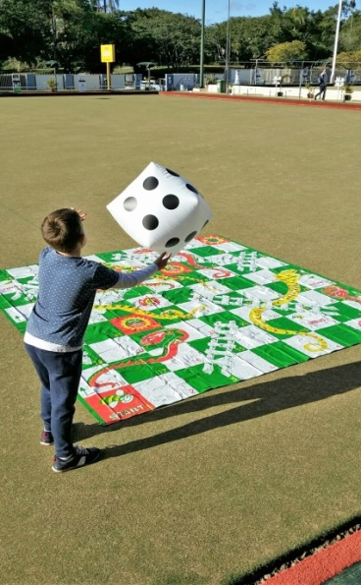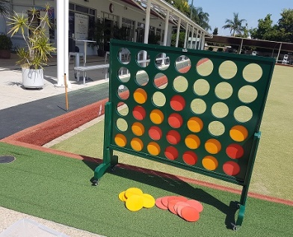

Seminars, Training days and Board Meetings
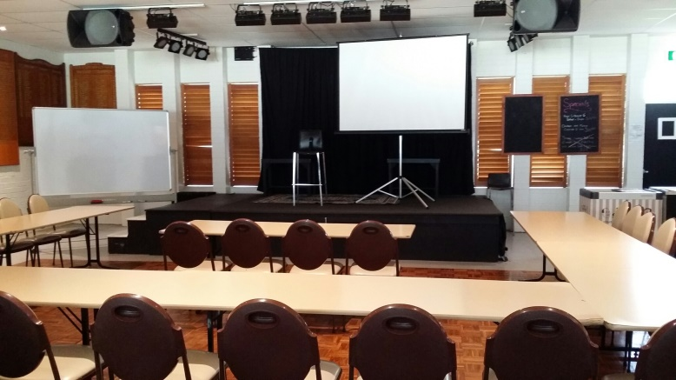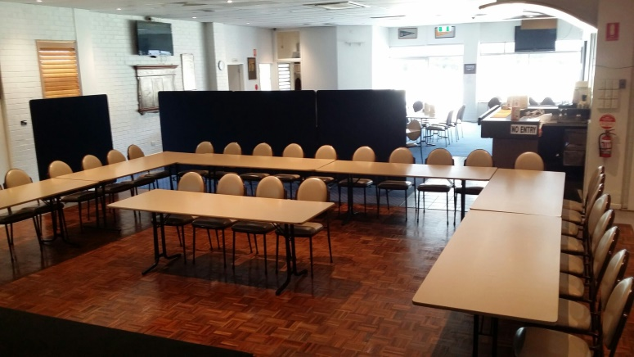

Choose New Farm Bowls Club for your next Seminar, Training Day or Board meeting.

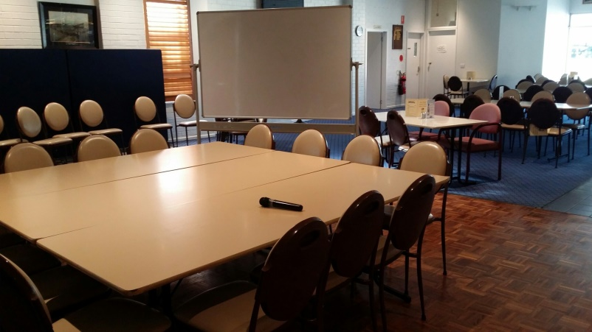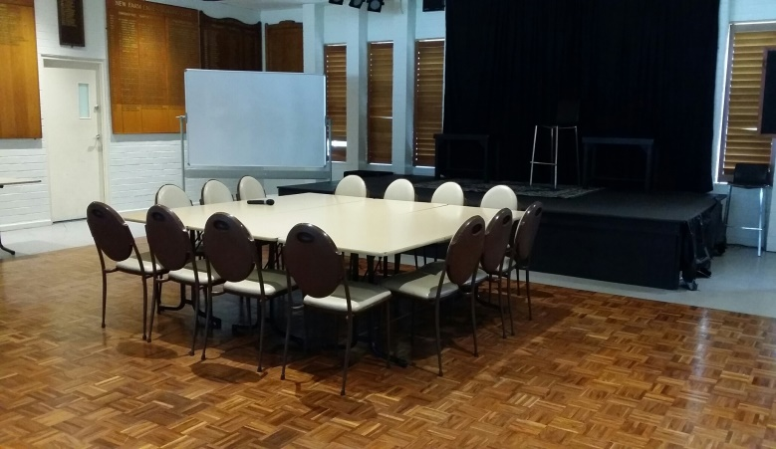

Only $100
Includes tea and coffee urn, white board, projector screen (no projector available, you will need to provided your own) and microphone, if required. Suitable for up to 80pp.

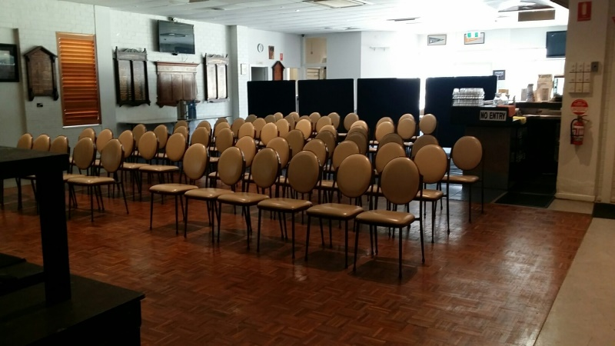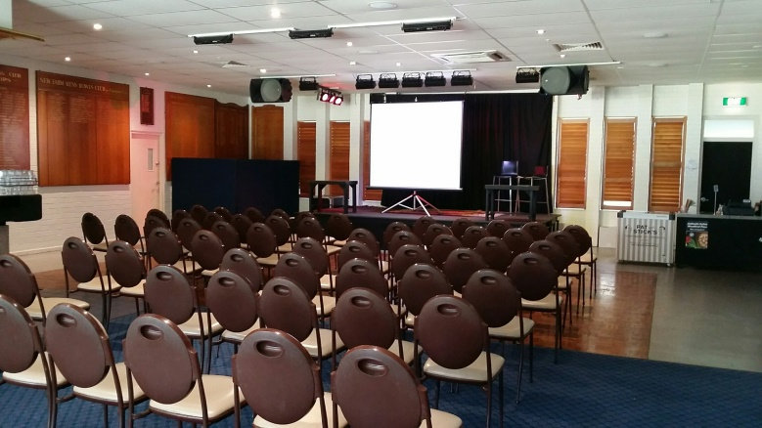

Our Function Room is not completely private and we suggest you come a view it for suitability. Please note we are not open to the public until 12 noon.
The Club can provide catering for those extra-long days. See below for menus.
Morning/Afternoon Tea Available from $7.50pp

Why not add Barefoot bowls to finish your day?
Catering
We cater for all dietary requirements.
Our Chef can plan a special menu for your event if required. Please mention this at time of booking.

Platters

Slider Burgers 15p $60
30p $120
Beef Cheese
Pulled Pork Coleslaw
Moroccan Chicken + Lime Aioli

Skewers GF 15p $60
30p $120
Tandoori Chicken
Asian Beef
Kasoundi & Dukka Lamb

The Squidley GF $80
Salt & Pepper Calamari
Chilli Calamari
Lemon Pepper Calamari

Antipasto GF sml $60
Lge $120
Danish Fetta, Olives, Salami, Sundried Tomato’s, Stuffed Peppers,
Smoked Salmon, Marinated mushrooms, Prosciutto & Bread (please request GF bread)

Wings GF 30p $40
60p $80
Southern Style (fried)
Sticky Tex BBQ

The Shorty GF sml $60
Lge $120
Pulled Pork, Lemon Pepper Calamari,
Southern Style Wings & Bread

Bowls Packages

Barefoot Bowls is included in all Bowls Packages

Burgers $24pp
Your choice of
Beef Burger
Steak Sandwich
Chicken Schnitzel Burger
All Served w Chips

BBQ (Buffet Style) GF $35pp
250gm Rib Eye
Pork Sausage
Chili & Lime Prawn Skewer
Caesar, Greek and House Salads
Mushroom Sauce + Condiments
Par baked Roll (please request GF Roll)

Deluxe GF
(Buffet Style on Request) $50pp

180g Petite Eye Fillet
Your choice of: 100g Crusted Barramundi
: 120g Atlantic Salmon
Pork Sausage
Chili & Lime Prawn Skewer
Rosemary Potatoes (not GF)
Caesar, Greek, House and Rocket, Pear, Cashew + Feta Salads
Mushroom Sauce + Condiments
Par baked Roll (please request GF Roll)

Dessert Add $7.50pp

Bistro Menu
Tuesday, Wednesday, Thursday, Friday nights

TBA

Bar Snacks

Beer Battered Chips
w gravy $6
Wedges
w sour cream, sweet chilli sauce $8
Vege Nachos NA$8
Fish Bites
w chips & tartare sauce $9
Southern Fried Chicken Wings
w dipping sauce $9
Salt & Pepper Calamari
w chips $10
Steak Sandwich w chips $14
Chicken Caesar Wrap w chips NA$14

Available
Tuesday to Sunday 12noon – 6 pm and Saturday 6 – 8pm

Bar
The New Farm Bowls Club does not do drinks packages. You are welcome to start a bar tab informing us of your drinks choices for e.g. Beer/ Wine/ Soft drinks or Tap Beer/ House Wine Basic Spirits/ Soft drinks. There is no minimum spend. Your guests are also able to purchase their own beverages.
Prices are available upon request.

TAP BEER – XXXX Gold, Tooheys New, Hahn Super Dry, XXXX GOLD Pale Ale, James Squire 150 Lashes, James Squire Orchard Crush
CIDER - Strongbow Cider, Sweet, Original, Dry, Bulmer’s, Rekorderling flavours 330ml
DOMESTIC STUBBIES - XXXX Bitter, XXXX Gold, XXXX Summer, Hahn Ultra, Cascade Premium Light, Little Creatures (Pale Ale + Bright Ale), Rogers, Coopers Pale Ale, Coopers Sparkling Ale, Stone + Wood Pacific Ale, James Squire The Chancer/Four Wives/Swindler, Peroni, Peroni Leggera, Corona, Stella Artois, VB, Tooheys Old, Carlton Mid, Carlton Draught, Asahi, Heineken, Guinness Can.
SPIRITS - Basic spirit glass with mix
READY TO DRINK - Bundy & Cola, Johnny Walker & Cola, Jim Beam & Cola, Jack Daniels & Cola, Smirnoff Red/Black, Canadian Club & Dry, Vodka Cruiser flavours
SOFT DRINK – Coca-Cola Cans, Bundaberg Ginger Beer/Sarsaparilla, Mt Franklin Mineral Water, Mt Franklin Still Water, Red Bull, Powerade
HOUSE WINE
Oxford Landing Estate Sauvignon Blanc 2015 Waikerie, SA
Oxford Landing Estate Chardonnay 2015 Waikerie, SA
Oxford Landing Estate Merlot 2014 Waikerie, SA
Oxford Landing Estate Shiraz 2014 Waikerie, SA
Gossips Sweet Moscato South East Australia
SPARKLING WINE
Redbank Emily Pinot Noir Chardonnay Brut Cuvee Piccolo NV King Valley, Vic
Redbank Emily Pinot Noir Chardonnay Brut Cuvee NV King Valley, Vic
Angus Brut Premium Cuvee/Moscato NV South Australia
Jansz Premium Non Vintage Cuvee NV Tasmania
Pol Roger Brut Non Vintage NV Epernay, France
WHITE WINE
Redbank ‘The Long Paddock’ Sauvignon Blanc 2015 Victoria
O’Leary Walker Blue Cutting Road 2014 Clare Valley, SA
Yalumba Y Series Pinot Grigio 2015 South Australia
Pitchfork Chardonnay 2015 Margaret River, WA
Jim Barry Lavender Hill Reisling 2015 Clare Valley, SA
Twin Islands Sauvignon Blanc 2015 Marlborough, NZ
Mawsons Sauvignon Blanc 2015 South Australia
RED WINE
West Cape Howe Rose 2015 Mt Barker, WA
Haha Pinot Noir 2014 Marlborough, NZ
Mawson’s Cabernet Sauvignon 2013 South Australia
Yalumba ‘Patchwork’ Shiraz 2013 Barossa, SA
Redbank Merlo 2014 Coonawarra, SA
Running with the Bulls Tempranillo 2014 Barossa, SA
The Barry Bros. Shiraz Cabernet Sauvignon 2014 Clare Valley, SA
Year may change without notice

Terms and conditions

1. Deposit
An invoice will be issued upon booking for all events requiring catering. A deposit of $200 is required to secure your booking. For bookings over 50pp or for Deluxe BBQ’s, $500 will be requested. The deposit amount will be debited from the balance of your invoice.

2. Payment
Final numbers and full payment (balance of invoice) is required 3 working days prior to event (see point 3). For large groups, payment may be required 7 working days prior to event. Changes to numbers after this time must be approved by management. Payment can be made by cash, credit card, eftpos, direct deposit and company cheque. Amex accepted with 3.5% surcharge. No diners.

3. October, November and December
A deposit of $100 is required to hold your booking.
Final numbers and full payment during this time is required 7 working days prior to your event.

4. Cancellations
Notice of cancellation made 30 days prior to event will receive a full refund of deposit, 14 days prior will receive 90% of deposit, and 7 days prior will receive 50% of deposit. Cancellations made after this time will forfeit deposit.
If cancellation is made by the Club, due to weather or other unforeseen circumstances, a full refund of the barefoot bowls component will be received. Catering cannot be cancelled due to weather. The Club is still open for you to enjoy the great food and the company of your guests.
5. Event Timing
It is the customer’s responsibility to ensure that their planned event runs on time. The Club will not be held responsible when guests are not punctual for the event. When barefoot bowls starts late, the specified finish time will still apply. BBQ’s must be served at your specified time. Please try to arrive at least 15mins before your event starts.

6. Minors
New Farm Bowls Club is family friendly and welcomes children bowlers (we have smaller bowls for the smaller kids). Children must be supervised at all times by a parent or carer. Minors are not permitted at the bar or in the Gaming Room. Alcohol will not be served to minors and proof of age will be asked for if necessary (failure to prove proof of age may result in refusal of service).

7. Music
New Farm Bowls Club does not permit any amplified noise in our outdoor areas due to Liquor Licensing restrictions.

8. Behavior
New Farm Bowls Club is situated within the neighborhood and we ask that you respect our neighbors both whilst at the Club and on departure. New Farm Bowls Club does not tolerate disorderly or drunken behavior, and said patrons will be asked to leave the venue. Refusal to do so may incur a fine.

‘A copy of the Privacy Policy of New Farm Bowls Club Inc. is available on our website. By signing this agreement, you acknowledge that you have read and agree to the terms of the privacy Policy of New Farm Bowls Club Inc.’
Terms and Conditions agreement
I, _____________________________________________ (print name) have read and agree to the Terms and conditions stated above for my event planned for ___________________ (Function date).
Signature: ________________________________ Date: ________________________________
Booking Form
Please fill in all areas and return to functions@newfarmbowls.com.au or Fax (07)3254 0074

Booking Name: ______________________________________________________________
Booking date: ________________________________________________________________
Company Name: _____________________________________________________________
Contact phone number: _______________________________________________________
Email address: ________________________________________________________________
Contact person at event (if not same as booking name): ______________________________
Preferred Area: _______________________________________________________________
Barefoot Bowls session: ________________________________________________________
Catering requirements:
Bowls Packages
Burgers Beef x __________ Steak Sand x ___________ Chicken Schnitzel x _________
Please circle
BBQ
Number of Adults: ______ Time of BBQ: ______Please note your BBQ will be served at this time
Vegetarians x ___________ Other Dietary requirements: ____________________________
Deluxe
Number of Adults: ______ Time of BBQ: ______Please note your BBQ will be served at this time
Your choice of: 100g Crusted Barramundi x _________120g Atlantic Salmon x _____________ Vegetarians x ___________ Other Dietary requirements: ____________________________
Platters
Sliders x __________ Skewers x ___________ Antipasto x __________
The Squidley x ________ Wings x ________ The Shorty x _____________
Time for platters: ________________________________________________
Dessert x __________________
Payment Details
Preferred option
- Direct Deposit BSB 034065 ACC# 232529 ACC NAME New Farm Bowls Club Inc.
Please quote invoice number as reference and forward remittance advice to functions@newfarmbowls.com.au
Credit Card
Please debit my Credit Card
MasterCard Visa Amex Please note a surcharge of 3.5%
Amount: $______________ Please circle Deposit Payment in full
Card number: __ __ __ __-__ __ __ __-__ __ __ __-__ __ __ __ Expiry Date: _____/_____
CCV: __ __ __ 3 digit number on back of card Name on card: _______________________
Signature: ____________________________________ Date: ___________________________
‘A copy of the Privacy Policy of New Farm Bowls Club Inc. is available on our website. By signing this agreement, you acknowledge that you have read and agree to the terms of the privacy Policy of New Farm Bowls Club Inc.’

